
Simultaneous transit of Venus and solar eclipse
as predicted by Solex for April 5, 15232 TT

SOLEX 11.0 User Manual and Technical Notes.
(Version 11.0, June 2010)
Aldo Vitagliano
Dipartimento di Chimica, Università di Napoli Federico II
Complesso Universitario di Monte. S. Angelo, via Cintia, I-80126 Napoli, Italy
E-mail: alvitagl@unina.it

- Introduction
1.0 About this manual. This manual describes the full performances of the registered version of the program. The unregistered (light) version is identical in its functions, but its world map file and its star, planetary and asteroid libraries are limited in size. In the “light” version the stars are limited to magnitude 8.5 and only 30000 numbered asteroids are included.
Apart from very minor changes, the version 11.0 of the software is almost identical to the previous version 10.2, with two very important “hidden” changes: the star library and two DLL’s are constructed differently, and therefore the software is not longer compatible with previous versions of the libraries (that’s why a new installation is required).
- The star library now contains 3D data, i.e. information on their distance and radial velocity, and the program uses this information to do a more accurate computation of the star proper motions over a wide time span.
- The previous graphic libraries gave malfunctions under Windows 7. The problem has now been solved.
All the rest is essentially the same as in version 10.2, and therefore the following of this manual is not changed compared to that of the previous version.
Features which are new to the 10.0 version compared to the 9.1 version are marked with (*New*). Features which are new to the 10.2 version compared to the 10.0 version are marked with (*New10.2*). See Section 1.2 for a summary of the major new features.
1.1 What is Solex and what does Solex do? The name comes from “Solar system integration by a fast extrapolation method”, and, indeed, Solex computes the positions of solar system bodies (planets, asteroids and comets) by a method which is entirely based on the numerical integration of the Newton equation of motion (upgraded to account for the major relativistic effects). This means that, once the position and velocity of each body is known at a given starting instant, the acceleration arising from the mutual gravitational forces is computed, and then the new position and velocity after a suitably short time interval (the stepsize) can be predicted. The procedure can be iterated, so that the whole orbits are generated. A beautiful and simple description of the general idea was given by Feynmann in his famous Physics textbook. The more sophisticated integration technique actually implemented by Solex, as well as the Solar System model adopted, have been described by the author.¹
On one hand the numerical integration approach introduces a limitation for the user: it is not possible to feed a date to the program and to get the planetary configuration in response. If the date were to be changed, the planets would still travel following their original clock. Planets must instead travel from the initial starting epoch to the desired epoch, and the time required depends on the time interval between the two epochs and on the machine speed. On a 3 GHz Pentium computer, one century orbiting of the Solar System (including the three major asteroids Ceres, Pallas and Vesta) takes less than 5 seconds. Still, if we were interested in the Christmas night sky of year 1 BC (astronomical year 0), starting from the present epoch (say January 1st, 2009), more than a minute would be needed to reach the desired epoch. This limitation is overcome by Solex by using a database of precalculated starting conditions, among which the program will choose the one which is closest in time to the target epoch. Therefore the initial “go to epoch” waiting time is reduced to not more than a few seconds (if the target epoch is within the time span covered by the library). After this affordable cost is paid, the reward comes back: whatsoever astronomical phenomenon is always dynamically reproduced. The Solar System is "alive", and the moving bodies can be seen from any point of view, static or dynamic, according to various coordinate systems and at variable speed, forward or backward in time. Everything combined with an unmatched precision, fully comparable to that given by the Astronomical Almanac, by the JPL Horizon system or by the MICA software (U.S. Naval Observatory) and generally superior to that given by computer programs implementing analytical methods. Libraries containing starting condition for more than 240,000 numbered asteroids and over 700 comets are available to the program, which can then integrate the “expanded” solar system up to any desired epoch (at a rate of up to 0.5 min/millennium on a Pentium 3 GHz machine). Besides the library objects Solex can easily handle custom bodies and also Earth’s satellites. Moreover, a fictitious Solar System can be loaded to the program, to model the gravitational dynamics of N-body systems and get insights on aspects such chaos, perturbing effects of heavy planets, relativistic effects of a very massive star and so on …
In conclusion, Solex 11 is a very precise ephemeris generator, a Planetarium, an advanced Celestial Mechanics' device and a serious research tool. Above all, it can be a self-instruction tool to be explored and enjoyed.

1.2.1 Major new features of Solex 10.0, compared to Solex 9.1
- Extended Precision (80 bits → 19 significant decimal digits) implemented for the numerical integrator.
- Higher order (18) available for the numerical integrator.
- New planetary libraries, based on the new JPL DE421 ephemerides (February 2008).²
- Enabled search for conjunctions to a custom celestial position of specified coordinates.
- Enabled search for oppositions and quadratures between solar system objects.
- Enabled search for multiple conjunctions to stars.
- Enabled search for stationary points in Right Ascension or Longitude.
- Osculating orbital elements can also be referred to the invariable mean plane of the solar system.
- New star library, based on the NOMAD 1 catalog, extended to visual mag. 12.0 (ca. 2.5 million stars)
1.2.2 Major new features of Solex 10.1, compared to Solex 10.0
- Enabled search for conditions of maximum distance between bodies (apoastra).
- Expanded “hide body” feature: file output and search for close approaches can now be restricted to any subset of bodies.
- Improved and updated DeltaT calculation (already implemented in revision 3 of Solex 10.0)
1.2.3 Major new features of Solex 10.2, compared to Solex 10.1
- Enabled search for condition of maximum angular distance (elongation) between two bodies.
- Geographic coordinates can be loaded from a large library of locations.
- Geographic coordinates of observatories can be loaded according to the observatory code.
- The text output screen has been expanded to include more data, according to the following:
- Angular coordinates (RA, DEC and LONG, LAT: rates of change of celestial coordinates are given.
- Orthogonal coordinates: components of velocity and radial velocity can be displayed.
- Horizontal coordinates: Rising, Set and Transit times are displayed

1.3 What Solex 11 does not do ? Although Solex 11 can accomplish a lot of advanced tasks related to the instantaneous positions and to the motion of Solar System bodies, it does not handle planetary satellites and the rings of Saturn. Also, Solex 10 does not compute physical ephemerides of the Moon and the planets, nor does display constellation boundaries or connectivity between stars belonging to the same constellation.
About the input-output functionality, Solex 11 does not support any direct output on a printer. However, printed hard-copies can be indirectly obtained by externally processing one of the many text or image files that Solex can write on disk.

1.4 Installation and Startup. The program is provided as a self-installing file (STUPS110.EXE). The program should be run in windowed mode, not in full-screen mode, either from a (pseudo) DOS prompt or from Windows. It is suggested to start the program from the Solex 11 Icon, corresponding to the startup file SOLEX11.EXE, which is located in the subdirectory BIN of the working directory. In this case a window will be created which is optimized for your screen resolution, and you will be prompted to choose between a window as large as possible or a smaller “font-optimized” window. Important for Win95/98/Me users: For proper functioning, when launched from a DOS prompt (SOLEX102.EXE executable) under Win95/98/Me, the program must run in a window in which the “Fixed font” option has been selected from the Window Properties/Font Menu (e.g. 7x12 or 10x18 etc.) rather than the “Auto” option. The above problem does not exist for Win 2000/XP users. The startup file SOLEX11.EXE (Solex 11 Icon) automatically takes care of selecting the most appropriate fixed font, according to your preferences (large or small window). After startup, pressing a key or clicking a mouse button will let the program prompt for the maximum magnitude of stars to be read from the library file. Simply pressing Enter or clicking a mouse button will enter the default value 7.0, any other value must be entered from the keyboard. After reading the star library, the program enters the Main Menu. In most cases, options that do not require explicit input of numeric data can be activated either by the appropriate keystroke or by mouse clicking on the word(s) describing the option.
Note: Some of the output of Solex is (or can be) on disk ASCII files, which can be accessed by the user via any text editor. Solex 11 can also produce BMP image files, which can be accessed via an image processor (e.g. MS Paint). All files output by Solex 11 are written in the working directory (typically C:\Programs\Solex110\USERDATA). Most of the files which are input by Solex 11, but should not be touched by the user, are in the subdirectory BIN, IMG and ASC of the working directory. Some configuration files that may be changed by the user are in the subdirectory CFG.
Important. The program can be started from a (pseudo) DOS prompt (CMD window) in any directory chosen by the user, provided the PATH line in the AUTOEXEC.BAT file has been upgraded with the path to the Solex10 working directory. In this case the input/output will take place in the chosen directory. The upgrade of the AUTOEXEC.BAT file is automatically done by the installation program. However, under Windows 7, to run the program from a DOS prompt in a custom directory, it is necessary to manually add the appropriate PATH (normally C:\Program Files\SOLEX110) in the menu “properties/system advanced settings/system variables” of the computer, and also create an environment variable called “SOLEX11DIR” and set it to the appropriate path (normally C:\Program Files\SOLEX110).
1.4 Conventions. Commands are not case-sensitive: upper and lower-case letters, when entered from keyboard, do have the same meaning. Through this document, Solex11 commands and all characters or words that are supposed to be input from keyboard are enclosed in square brackets, commands are in bold typeface.
1.5 Performance extension. By default, Solex11 can handle up to 8016 bodies simultaneously. This limit can however be extended to any value by starting Solex from a command line, and adding to the program name a blank, followed by the maximum number of bodies which the program should handle. For example, by typing SOLEX110 242000 it will be possible to load all the over 240,000 asteroids of the extended library. This complication is motivated by the need to avoid the allocation of a large unused memory, which in some systems slows down the execution speed.

2. Main Menu.
2.1 Main Menu Options. The Main Menu presents the following options:
[1]. DE421. *New* The starting conditions for the numerical integration are read from a library fitting the latest JPL DE421 ephemerides (2008).² Obliquity and precessional angles are computed using Laskar and Williams’ formulae.³ The library time span is from –30000 to +30000. The nine planets and the three major asteroids are included. The main reason to include this library was to provide a way to estimate the accuracy of long-term predictions, by comparing the output obtained with different sets of starting conditions (DE406 vs. DE421). The library based on DE200 positions is obsolete and has been removed. Both the planetary and the lunar positions are supposed to be more accurate for the DE421 options.
[2]. DE421. Planets only. *New* Same as above, but the Moon and the 3 major asteroids are missing, and the library is extended to a time span of +/- 150,000 y. The integration speed is more than twice faster. Important Note: Since the Moon is missing from the system, in this case the “geocentric” coordinates are referred to the Earth-Moon barycentre, and therefore are not truly geocentric. Also, the “topocentric” coordinates are referred to a fictitious Earth placed at the Earth-Moon barycentre.
[3]. DE406. Starting conditions are read from a library fitting the JPL DE406 ephemerides. Obliquity and precession angles are computed using Williams’ formulae.³ The library time span is -30131 to +30085. The nine planets and the three major asteroids are included. This option corresponds to the ephemerides currently given by the Astronomical Almanac.
[4]. DE406. Planets only. Same as above, but the Moon and the 3 major asteroids are missing, and the library is extended to a time span of +/- 150,000 y. The integration speed is more than twice faster. Important Note: Since the Moon is missing from the system, in this case the “geocentric” coordinates are referred to the Earth-Moon barycentre, and therefore are not truly geocentric. Also, the “topocentric” coordinates are referred to a fictitious Earth placed at the Earth-Moon barycentre.
[5]. 406sh. The library fits the JPL DE406 ephemerides, but does not include Pluto and the asteroids. Due to the lower number of bodies, the integration speed is about twice faster than with the “full” library. The library span is from –3000 to +6000.
[6]. Min. Bodies File. Starting conditions for up to 8000 minor bodies (see section 1.5 for extending the default number) can be read from a custom file. The starting condition can be given either as status vectors (positions and velocities) or as classical osculating elements. The solar system starting conditions are read from the last-called library (or from DE406 if the option is called at startup), but if the bodies are satellites, the solar system is limited to the planets from Venus to Saturn and to the Moon. The default extension for the custom files is .SLX (only files with this extension will be listed in the input window), but any filename can be used. The detailed format of the input file is described later (see section 2.3.1).
[7]. Full N-Body File. The starting conditions of all bodies (up to 8016 bodies, see section 1.5 for extending this number) can be read from a custom file, which can contain either positions and velocities or classical elements. The default extension of a “full” file is .SLF. By this option not only a "real" solar system situation can be read into the program, but also a completely fictitious one.
The detailed format is described in section 2.3.2.
[8]. Asteroid Library. Starting conditions for up to 8000 asteroids (see section 1.5 for extending this default number) can be read from an asteroid library. (Entering such a large number of bodies can be convenient only if the user intends to run a search for close approaches by the command [Y] in the main menu. Indeed, the tabular display can only show the first 1015 bodies). The extended library contains osculating elements of 241,562 numbered asteroids at the epoch 2010/07/23 taken from Bowell and AstDys databases:
(ftp://ftp.lowell.edu/pub/elgb/astorb.html, http://hamilton.dm.unipi.it/astdys/)
The same library allows to switch between four different options: Average (default): the elements are set to the arithmetic mean of the (different) values given by the two databases, and uncertainty estimates are computed by the corresponding positional differences and their time derivatives. Astorb: The data are taken from the Bowell’s AstOrb database. AstDys: The data are taken from the AstDys database. TwinLib: A couple of “twin” asteroids is generated, using each of the two database, respectively. Asteroids can be selected by number, by name, by number range, or from a custom list file. For example entering [1-25] will select all the asteroids up to no. 25 Phocaea; entering [MYAST.LST] will select all the asteroids listed (by number or by name, one asteroid for each line) in the text file MYAST.LST (the extension .LST is mandatory). When creating a long list file, it is suggested to use numbers rather than names, in order to speed up the search procedure. A useful list of Near Earth Asteroids is provided with the file NEO.LST. Asteroids can also be “filtered” according to the criteria stated in the file FILTER.AST, by entering a range, followed by a slash and letter F, e.g. entering [1-10000/F] will load, among the first 10000 asteroids, only those which meet the criteria selected by the editable file FILTER.AST. Finally, “clones” of each selection can be generated. For example, entering [Apophis/C16] will generate 15 “clones” of asteroid 99942 Apophis (besides the parent one), whose orbital elements are randomly distributed around their nominal values in a way matching the estimated standard errors of the parameters.
Multiple successive selections are allowed. The solar system starting conditions are read from the last-called library (or from DE406 if the option is called at startup.
[9]. Comet Library. Starting conditions for a comet can be read from a comet library, containing position and velocity vectors given by P. Rocher (http://www.imcce.fr/page.php?nav=en/ephemerides/) in the ASCII file catalog and including non-gravitational parameters. A comet can be selected either by its official designation (e.g. [46P] or [P/2000 C1]) or by name (e.g. [Wirtanen] or [Hergenrother]) or by browsing through the whole list. The starting epoch is the epoch of the elements given by BDL and depends on the particular comet. The solar system starting conditions are read from the last-called library (or from DE406 if the option is called at start).
[0]. Reload Stars. Useful to change the upper magnitude limit. The star library (*New*) is based mainly on the NOMAD1 catalogue. Positions from the PPM catalogues are used for ca. 60 bright stars missing in the NOMAD catalogue. Important Note: If a very large number of stars is loaded into memory (typically when the limit magnitude is above 10.5) the computation time involving the stars (graphic display of stars or star conjunction search) can be disturbingly slow. In these cases, if the user is interested only in a specific region of the sky, the stars can be “filtered” during loading, matching a specified rectangular region of RA and decl. This can be done by entering the limit magnitude, followed by [/F], and then entering the appropriate values for the RA and decl window.
[S]. Special Options. Nine special options are available.
The first one (A) allows to change the Lunar tidal acceleration parameter from the default value (fitting the DE406 or the DE421 ephemerides) to a custom value. The value is reset to default every time the Main Menu is entered. If the option is activated, the initial conditions are read from the library record which is closer in time to J2000 rather than to the target epoch. Therefore, a long “go-to-epoch” initial computing time is required if a distant target epoch is to be reached.
The second special option (B) allows to neglect the perturbations acting on minor bodies by selected major planets. The planets to be neglected can be selected/deselected by right-clicking on the corresponding name in the text-output window.
The mutual perturbations between major planets remain active.
The third option (C) *New* switches on the perturbations exerted on major planets by minor bodies, which are normally not considered. Note that mutual minor body-minor body interactions are never considered, unless the starting conditions are read from a “full” .SLF or .ELE file (see Appendix 1 for details).
The fourth option (D) *New* switches off the relativistic perturbation acting on minor bodies, the major planets remaining affected. This is only useful for “measuring” the relativistic effect on orbits closely approaching the Sun, by comparison of the default output with that obtained after switching “off” the correction.
The fifth option (E) *New10.1* switches off all non-Newtonian-point mass perturbations for all bodies.
The sixth option (F) allows determining how the solar mass loss is handled by Solex. In the default mode, the solar mass loss is not considered within the time interval -3000 to +3000, for consistency with the JPL ephemerides, but considered outside this interval. In the other two modes the solar mass loss can either be ignored everywhere or be forced everywhere (including the interval -3000 to +3000). It should be remembered that the library data are computed using the default option. Note that the quadratically growing effect of the solar mass loss affects the time at which planetary events (such as conjunctions) take place, but does have a negligible influence on the events themselves, i.e. the same planetary configurations are reproduced at a different time, with the exceptions of those involving the Moon.
The seventh option (G) *New* sets the order of the numerical integrator. The default order (14) is OK for all the cases involving relatively “short” integrations (i. e. shorter than a few thousand years). For preserving a good numerical accuracy in longer integrations, it might be advisable to adopt a higher order (16 or even 18). However higher order also means more computations and longer integration time.
The eighth option (H) *New* allows the use of extended precision arithmetic when computing planet-planet interactions.
By default the extended precision arithmetic is used only when computing Sun-planet and Earth-Moon accelerations, because the planet-planet forces are normally much smaller and the extra digits gained by the extended precision would be lost anyway when adding up the acceleration. The option may be useful in the case of minor bodies undergoing repeated approaches to a major planet at a distance where the planet-body force becomes comparable or even larger than the Sun-body force.
The last option (H) *New* is useful in dynamical studies on many-body systems. When activated, collisions between a major planet and a minor body are detected, the minor body is removed from the system and its mass and momentum are added to the major body.

[Esc]. Quit. Exit program.

2.2 Input of Date and Tabulation Interval.
2.2.1 Date. If one of the options 1-3 is selected, the program prompts for a starting date. This has to be entered from keyboard in either of the two formats [YYYY,MM,DD] or [YYYY.MMDD]. However, there are a few shortcuts:
- If the [ENTER] key is pressed in response to the prompt, or mouse is clicked, the current system date (at 0 TDT) is adopted.
- If only [YYYY] is entered, the date is set to January, 1st of year YYYY.
- If only [YYYY] and [MM] are entered, the date is set to the 1st day of the month MM.
DD is not necessarily an integer number, so that for example entering [2002.060133333333] (or [2002,6,1.33333333333]) will start the tabulation at 8.00 TDT of june 1st, 2002.
In options 6-9 the initial date is read from the appropriate data file. To reach a different epoch, the command [J] (Jump to Date) in the Commands menu has to be used.
- If the date input is followed by [/L] then the program jumps at the library date which is closest in time to the selected epoch.
2.2.2 Tabulation Interval. This has to be entered from keyboard in the format [dd.hhmmss]. For example to set a tabulation step of 15 days, enter [15]. To set a tabulation step of 30 min, enter [0.0030]. Pressing just the [ENTER] key sets the tabulation step to 1 d. A negative entry causes the program to run backwards in time after the target epoch has been reached. The tabulation interval can be successively multiplied/divided by discrete factors through the commands [U] (Time Unit) and [S] (Step Scaling).

2.3 Input Files. When the options numbered 1-5, 6 or 7 are selected, SOLEX 11 reads its input data only from library files (*.BIN) and accessory files (*.DAT), whose internal structure is not a concern for the user. When the options numbered 6 or 7 are selected, SOLEX 11 reads part (or all) of the data from a file (*.SLX or .SLF, respectively) which must be created by the user. There are three basic ways of creating such files: i) manual editing; ii) renaming or copying the SOLEX 11 output file FINAL.SLX, FINAL.SLF, FINAL.SLE or FINAL.ELE; iii) renaming or copying the EXORB output file START0.DAT. The extensions .SLX and .SLF are not mandatory for an input file, but only filenames having these extensions will be displayed in the input window. The file FINAL.SLE contains the same starting conditions as the file FINAL.SLX, in the format of osculating elements instead of position and velocity vectors. The file FINAL.ELE contains the same starting conditions as the file FINAL.SLF, in the format of osculating elements instead of positions and velocity vectors.
2.3.1 Minor Bodies’ Files (*.SLX). This file can contain starting conditions (pv vectors or osculating elements) of up to 8000 minor bodies (see section 1.5 for extension of this limit), provided they all refer to the same starting epoch and provided classical elements are not mixed up with positions and velocities. The number of digits or characters used by alphanumeric data is free, as is the number of spaces used to separate each item in a line. If numbers are written in exponential format, either the letter E or the letter D can be used, in both lowercase and uppercase form (1.03445E-01, 10.3445d-02, 0.103445, or 1.03445D-1 are equivalent). The data in the file must be structured as follows.
Line 1: One entry. Epoch (JD) of the elements. Very important: if the files contains classical osculating elements, then the epoch must be set as negative (as an implicit flag telling to the program what to expect). If the data refer to a satellite, then the number 90,000,000 (or –90,000,000 in the case of classical elements) must be added to the epoch (as another implicit flag telling to the program that it is a satellite and the elements or pv vectors are geocentric). So, the number –92451544.5 in line 1 means that the following data are geocentric osculating elements of satellite(s) at epoch January 1, 2000, 00h TDT. Note: What stated above implies that starting conditions for minor bodies referring to epochs before JD 0 (–4712, January 1) cannot be stored in a SLX or SLE file. In such cases, the “full system” SLF or ELE files (see below) must be used.
Line 2: Five entries. + *New* optional epoch of elements + optional color code
1: If the body is not a comet, then this entry is the mass of the body, in units of 10^24 kg (in these units, the mass of the Sun is 1989095.324, that of Earth is 5.974227112). Important: Do not bother about the mass! The mass is only needed in special cases when the user wants to investigate perturbations by large asteroids (See Appendix 1 for details). Normally, the mass is not needed (a zero value is OK) and, if a non-zero value is present, it is not used (defaults to zero). Important option *New* : In the case the orbital elements are not referred to J2000.0,but to some other epoch (a frequent case with old data) this entry (mass or k magnitude) can be set as negative, which is an implicit flag telling the program to read a further number as the fifth entry (before the body’s name). This number should be the number of julian days from J2000.0 to the epoch to which the elements are referred. For example, if the epoch is B1950.0 the number should be -18262.5765.
If the body is a comet, the 1st entry is the k magnitude parameter (the mass always defaults to zero).
2: Radius of the body, in units of Gm, i.e. millions of km (in this unit, the equatorial radius of Earth is 0.00637814). The radius is relevant in eclipses and occultations studies. Important: If the body is a comet, the radius must be set as negative, as an implicit flag telling the program that the body is a comet.
3: Absolute magnitude.
4: Relativistic parameter (don’t bother about it; if the file is manually edited, just set it to zero).
5: Optional. Epoch of orbital elements, if not J2000, expressed as number of days from J2000.0. Important: if this datum is inserted, the mass (or k magnitude when comet) must be set as negative to flag the presence of the datum.
5 (or 6): Name of the body.
6 (or 7): Optional color code. A six digits number: the last (least significant ones) two give the amount of red (from 00 to 99), the middle two give the amount of green (from 00 to 99) and the first (most significant) two give the amount of blue (from 0 to 99).8
Line 3: Three entries. Either X, Y and Z equatorial heliocentric coordinates (gigameters) or e, i and ω ecliptic elements (eccentricity, inclination and argument of perihelion in degrees). Note: if the body is a satellite, the elements must be equatorial and geocentric.
Line 4: If the entry in line 1 is positive (file contains status vectors) then this line contains three entries. Vx, Vy and Vz, that is heliocentric equatorial velocity components (km/s).
If the entry in line 1 is negative (file contains classical elements) then this line contains five entries.
Ω, a, M0, q, Tp (Node, semimajor axis, mean anomaly, perihelion distance and time of perihelion)
Note: Either a and M0 or q and Tp must be set as zero. Angles are in degrees and distances are in AU. If the body is a satellite, the elements must be equatorial and geocentric.
Line 5: Four entries.
- If asteroid, all four entries can be set to zero (the first one must be set to zero). However, the second and third entries are interpreted by the program as the positional uncertainty (km) of the asteroid and its time derivative (km/y), respectively.
- If comet, the entries are the non-gravitational parameters A1, A2, A3, AF (AF is a scale factor usually set to 0.1113).
- If satellite, the entries are Qd (Drag empiric coefficient); QE2 (proportional to the Oblate Earth's J2 coefficient);
QE3 (proportional to the Oblate Earth's J3 coefficient); QEX (free for future implementations). If both QE2 and QE3 are set to zero, the program assigns default values to them, otherwise, they might be optimized for a specific satellite by using EXORB.
Line 6: Same as line 2 if another body is present and so on …, otherwise no line.
Important: No blank line must be left after the last one. The total number of lines must be (N*5+1) where N is the number of bodies included in the file. See the DEMO.SLX file for an example. Examples of the structure of SLX files are given by the FINAL.SLX and FINAL.SLE files, written by Solex when asteroids or comets are loaded from the respective libraries.
2.3.2 Full N-Body Files (*.SLF and *.ELE). The format of these files can be seen looking at the files FINAL.SLF and FINAL.ELE, written by the program every time the program runs. The former contains the starting conditions in form of status vectors (position and velocities), the latter contains the same data in form of classical osculating elements.
The first line of the file is the epoch (Julian day) of the starting conditions. The first entry in the second line of the file gives the default integration stepsize that is to be used by Solex. This is normally 3 d or 6 d for the solar system, depending on whether or not the Moon is included in the file, but can be set to more appropriate values in the case of fictitious planetary systems. A decent choice is about 1/20th of the period of the fastest orbit. (See below for further information about the FINAL.SLX and FINAL.SLF files). SLF files can contain starting conditions in the form of position and velocity vectors, or osculating elements. A negative stepsize in this case flags the program to interpret the data as osculating elements. Differently from SLX files, a negative Julian day plainly means an epoch before y –4712 and does not have a flag value.
The following entries in the second line are Mass of the central body (normally the Sun, in units of 10^24 kg), radius (in units of Gm = millions of km), two zeros and the name. For the first body (the Sun), the next two lines always contain a triplet of zeros.
For the following bodies, the first line gives the mass (in units of 10²⁴ kg, radius (in Gm), absolute magnitude, a relativistic parameter (see section 2.3.1) and the name of the body. The following two lines contain either Position-Velocity vectors X, Y, Z and Vx, Vy, Vx (in Gm and km/s, respectively), in the J2000 equatorial frame, or classical osculating elements e, i, ω and Ω, a, M0
Note that in the case of comets the full (*.SLF) files do not contain the non-gravitational parameters (or positional uncertainty estimates in the case of asteroids). If these are needed, the minor-body files (*.SLX or *.SLE) must be used instead. Important: If an SLF file contains asteroids, their masses are considered by Solex 11 (they do not default to zero as for SLX files). The use of SLF files is actually one of the two ways by which the masses of minor bodies can be taken into account (see Appendix 1).

3. Tabular Output Command Menu.
After the starting data have been entered, the program reads the solar system starting conditions from the appropriate library and integrates up to the target epoch. In the case of options numbered 6, 8, and 9 the data for the additional minor bodies are then added in memory. At this point, two full N-Body files named FINAL.SLF and FINAL.ELE are written to disk in the working directory, the latter containing the starting conditions in form of osculating elements. If minor bodies are present, two Minor-body files named FINAL.SLX and FINAL.SLE are also written to disk, the latter containing the starting conditions in form of osculating elements. The output screen for the target epoch is displayed, together with the menu of the available commands and/or toggles. Note that although up to 8020 bodies can be simultaneously handled by the program (see section 1.5 for extending the default number), only data for the first 1015 bodies will be displayed.
Since the action of many commands is rather obvious (or becomes so after a couple of trials), in the rest of this section only commands which might require more explanations are commented.
3.1 [W] Graphic Window. Switches to Graphic (Planetarium) mode, creating a Graphic Window and displaying a Graphic Menu (see next section for the Graphic Menu commands). When switching to Graphic mode, all the options selected in the Main menu are retained. Some of them can be changed from within the Graphic Command Menu, some cannot be changed without exiting the Graphic mode. Details are given in the next section.
3.2.1 [O] Orthogonal Coordinates. The distance from origin has been added to the output s *New 10.2*.
In this case the output distance is “apparent”, i.e. is affected by light time and aberration if these toggles are ON. Tne *New 10.2* command [^] Display Velocity outputs the components of the velocity vector relative to the origin and the radial velocity, affected by light-time and aberration if the toggles are ON.
3.2 .2 [T] Topocentric Coordinates. For proper use, before activating the topocentric coordinates, the appropriate Geographic Coordinates should be set by the command [G]. However, if the Graphic display is what you need, this can be done graphically from within the Graphic menu. Note that the activation of topocentric coordinates automatically activates the use of DeltaT, i.e. the UT as time unit instead of TT. If topocentric coordinates are successively turned off, the DeltaT is turned off. To turn it on again (if UT instead of TT is desired), the command [D] must then be used.
3.3 [C] PlanetoCentric Coordinates. Note that the orientation of the reference frame remains bound to the Earth-based celestial reference system, i.e. the Ecliptic and Equator. Horizontal coordinates are not allowed if this option is ON. Besides setting the origin on any chosen body, this option allows to set the origin on a fixed point, whose orthogonal equatorial coordinates must be entered by the user. The latter option is especially useful to get a picture (in the graphic mode) of the Solar System as seen from “outside”, possibly with the background of the stars. Note: It is possible to get barycentric positions by setting the fixed point to 0, 0, 0.
3.4 [Z] Horizontal Coordinates. Automatically sets the origin on Earth. The appropriate Geographic Coordinates have to be set by the command [G]. In the Tabular output mode, this is the only way to display approximate magnitudes of the bodies. The visual magnitudes are computed with the formula appropriate to either a minor planet or to a comet according to the case. Formula for a comet: m = g + 5 log(Delta) + K log(r)
Please note that magnitudes are approximate ! The error ranges from 0.0 to 0.3 units for the planets and from 0.0 to 1.0 units for the asteroids. Rising, setting and transit times, rounded to the closest minute, are given. *New 10.2* Note: If the body is above the horizon, the program gives the previous rise time and the next set time. If the body is below the horizon, the program gives the previous set time and the next rise time. If the hour angle is positive, the program gives the past transit time, if negative it gives the next transit time.
The rising and set times can be referred to the upper limb or to the centre of the body by toggling ON/OFF the command [)] Limb Ri/Set. The effect of atmospheric refraction on rising and set times can be toggled ON/OFF by the command [@] Refrac Ri/Set.
3.4.1 [R] Reference Equinox. All the output can be referred to the ecliptic, equator and equinox of a custom epoch, which must be entered as year and fraction of year (1900.0 means 0 TT of January 1, 1900; 1900.2464 means 0 TT of April, 1, 1900).
3.4.2 [D] DeltaT. Allows setting the value of DeltaT, either in Auto mode (using the formulas given in Section 7), or as a fixed value, or by a custom second order polynomial whose coefficients are entered by the user.
3.5 [X] Osculating Elements. The output shows osculating elements (referred to J2000) instead of positional ephemerides. Four toggles plus the File Output option are available. The command [M] dumps the current screen to a file named OSCEL.DAT. The toggle [D] switches the elements from being referred to the standard ecliptic and equinox of J2000 or to the mean ecliptic and equinox either of the ephemeris date or the date set by the Reference Equinox (command [R]). The Toggle [Q] switches the elements between Ecliptic, Equatorial or (*New*) Mean Plane elements.
3.6 .1 [V] Adaptive Stepsize. The “normal” status of this toggle is off and the command should not be a concern for the user, unless the loaded data contain a minor body undergoing close approaches with major planets or the Sun. Under the latter circumstances the default integration engine does not give accurate results, and the adaptive stepsize control should be toggled on. In this case the integration speed is reduced by about 30%. See section 5.3 for more details.
3.6.2 [/] Hide Planets. (*New10.1*) Selected planets can be hidden by using this option. When the toggle is on (green) it means that at least one body is hidden. Hidden bodies are excluded from file output and from any search for close approaches. The option is particularly useful to get a desired subset of close approaches and multiple conjunctions.
3.6.3 [!] Extra options. (*New*) The special options described in section 2.1 (command [S] of the main menu) can be activated or modified from within the text output menu. However, the Moon tidal acceleration and the Solar mass loss factor can be changed only from the Main Menu.
3.7 [F] File Output. The output (in the current optional settings) can be redirected to files. The program prompts for the number of records to be written on disk and for the time unit to be used in the output. When expressed in Julian years, centuries or millennia (options Y, C and M, respectively), the time is measured from J2000. The file OUTPUT.LOG will contain a sequence of “pages” as they would have appeared on screen. This file is written only when less than 4096 records are required to be written on disk. The files “*.OUT” will contain successive records, all referred to the same body. The output can be limited to the minor bodies or to the major planets. When the final epoch is reached, the files FINAL.SLF, FINAL.ELE, FINAL.SLX , FINAL.SLE and FINEL.DAT are rewritten (the latter three only if minor bodies are present).
Note: If more than 1015 bodies are loaded to the program, only data for the first 1015 bodies will be recorded. Be aware than when many bodies are loaded, the output on so many files will considerably slow down the program execution, especially if a short tabulation step has been selected.
3.8 [U] Time Unit. The default time unit is day, but can be switched to h, m, or s. If this is done, the tabulation step is scaled to the new unit (if it was 1d will become 1h or 1m and so on).
3.9 [S] Step Scaling. A further way of changing the tabulation step. If the original tabulation interval was set at the default value of 1d, the range of steps actually available by a combination of [U] and [S] toggles is from 0.001 s to 1000 d.
3.10 [G] Geographic Coordinates. Prompts for manual input of the latitude and longitude (and height on the sea level) of the observation site, or for loading them (*New 10.2*) from a location library or by observatory code. The location library contains all major cities in the world (more than ca. 50000 inhabitants). Try it just by entering the name of the city closest to you. The input of latitude and longitude can be done graphically from within the Graphic menu (see next section). Note that the site coordinates will not be active unless the Topocentric Coordinates option [T] is on.
3.11 [J] Jump to Date. This command is most useful when the Asteroid or Comet libraries (or the File options) are used, in order to jump to any target epoch starting from the library (or File) epoch. When the target epoch is reached, the files FINAL.SLF, FINAL.ELE, FINAL.SLX, FINAL.SLE and FINEL.DAT are rewritten (the latter three only if minor bodies are present). Note that these files can be renamed and directly used as custom files by the starting options numbered 6 and 7. Also note that the FINAL.SLX and FINAL.SLF files are in the format of position/velocity files, while the files FINAL.SLE and FINAL.ELE are in the format of osculating elements files.
3.12 [Y] Close Approaches. A major feature in Solex 11. Allows to perform a systematic search for close approaches between the currently loaded bodies and for other special circumstances. The use of this function is the only reason why it can be convenient (and allowed) to load a very large number of bodies to the program. This command presents the following seven options, that in turn can be “modulated” by the addition of a sub-option:

3.12.1 Spatial approaches. Close approaches within a given distance (in units of 1000 km) can be searched either between a selected body and all other bodies, or between all the bodies, or between a specified couple of bodies, or between (*New*) a range of bodies and all the bodies. Approaches between Earth and Moon are not considered. The program first prompts for selecting a body. To search for all mutual encounters [-1] must be entered, (simply pressing [Enter] will search for encounters with body #0, i.e. the Sun. Entering e.g. [Iris] will search all the encounters between asteroid Iris and all the other bodies (provided of course Iris was loaded from the Asteroid library). Entering [3/4] will search for the approaches between body No. 3 (Earth) and body No.4 (Mars). Entering [2-4] (*New*) will search for the approaches between the bodies 2, 3 and 4 and all the bodies (thus neglecting the mutual approaches between the bodies having a progressive number different from 2, 3 or 4). After prompting for the maximum distance to consider as a close approach (in units of 1000 km), the program prompts for a final epoch to reach and starts the search, displaying some information about its progress (progress bar, speed, number of hits etc …). An additional option (*New10.1*) is that the maximum distances between bodies (such as aphelia) can be alternatively requested, by entering [/A] immediately following the number indicating the maximum distance to be considered. The results are finally displayed on the screen and written to disk in the file MINDIST.DAT. A list of the bodies giving close approaches is written in the file CLOSAPP.LST, suitable to be used to reload from the asteroid library the starting conditions of only the asteroids that have given close approaches. In the case an impact is detected, data are written to the file IMPACT.DAT. If the planet where the impact takes place is Earth, then the geographic coordinates of the impact site are also written to the file.
Each line of the file MINDIST.DAT contains the following columns:
#1 & #2: Number of the bodies. Planets (including Ceres, Pallas and Vesta) are assigned negative numbers coinciding with their progressive number in the Solex usual tabulated list. Asteroids (excluding Ceres, Pallas and Vesta) are assigned
their official number. Comets and other bodies are assigned #0.
Date and Time: epoch (TT) of minimum distance between the two bodies.
JD2000: number of Julian days from epoch J2000.0 (2000, January 1.5)
Dm: minimum distance (in units of Gm, i.e. million km).
V: relative velocity (km/s) at the minimum distance.
pImp: Logarithm (base 10) of the ratio between Dm and the impact distance (sum of the radii).
pDefl : Negative logarithm of the deflection angle (arcsec) undergone by the lighter body as a
consequence of the close approach. (The deflection angle is 10^{-pDefl} arcsec).
pDa : Negative logarithm of the relative change in semimajor axis undergone by the lighter body upon the close approach. (da/a = 10^{-pDa}).
pDn : Negative logarithm of the mean motion variation (arcsec/y) undergone by the lighter body as a
consequence of the close approach. (The mean motion variation is 10^{-pDn} arcsec/y).
Error: estimated uncertainty (Gm) in the minimum distance (only in the case of asteroids).
Long & lat: ecliptic longitude and latitude (J2000) of the 1st body at the epoch of minimum distance.
r1 & r2: heliocentric distances (AU) of the two bodies at the epoch of minimum distance.
In the final two columns are the names of the two bodies.
Important: For proper handling of close spatial approaches between asteroids and planets, it is necessary to activate the option [V] (adaptive stepsize).

3.12.2 Angular approaches. Close conjunction within a given geocentric, topocentric or planetocentric angular distance are searched between all bodies (excluding the Moon) or between a selected body and all the others, or (between a selected couple of bodies, or between the first K bodies and all bodies. After prompting for selecting a body (see section 3.12.1 above), for the maximum angular distance (in degrees) to be considered, and for the final epoch to be reached, the program starts the search, displaying progress information. Conjunctions in Right Ascension (or conjunctions in Longitude according to the selected coordinate system) can be searched rather than minimum angular distances by entering [/C] after typing the selection of the body. Multiple conjunctions (simultaneous conjunctions of 3 or more bodies) within for example 2 degrees can be searched by entering [2/m] as the program prompts for entering the maximum angular distance (entering [2/m4] will restrict the search to multiple conjunctions within 2 degrees involving at least 4 bodies). Note: If the search is run under topocentric coordinates, events taking place more than 30° below the horizon are not recorded.
*New* Similarly to conjunctions in RA or longitude, opposition and quadrature conditions can be searched by entering the sub-command [/O] or [/Q], respectively, after the value of the angle (which must be a dummy value in the case of oppositions and quadratures). Maximum elongations [/E] from a given body *New 10.2* can also be searched. Note that oppositions, quadratures and maximum elongations can only be searched when a single target body has been selected.
The results are in part displayed on screen and written to a number of files:
MINDIST.DAT. The column headings and the corresponding data are the following:
#1 & #2: number of the two bodies (see details given above for spatial approaches).
Date & Time: epoch of closest apparent (i.e. corrected for aberration and light-time) angular separation (TDT if geocentric, TU if topocentric coordinates are selected).
Dm: Minimum apparent angular separation (degrees).
Dl: This is shown when geocentric (or planetocentric) coordinates are selected. Gives the limit angular separation for observing a mutual occultation. If Dm < Dl then an occultation can be observed somewhere on the surface of the center planet.
Alt: This is shown when topocentric coordinates are selected. Gives the altitude on the horizon of the 1st body at the time of minimum angular distance.
Err: Estimated angular uncertainty (degrees) of Dm.
RA & Dec: Right ascension and declination (in degrees) of the 1st body at the epoch of minimum separation, referred to the mean equinox of date. If ecliptic coordinates are selected, ecliptic Longitude and Latitude are given rather than RA & Decl.
r1 & r2: Geocentric (or planetocentric) distances (AU) of the two bodies at the epoch of minimum separation.
p : Position angle (degrees) of body #2 with respect to the center of body #1 at the minimum angular separation, measured counterclockwise from North = 0.
e: Elongation (degrees) from the Sun of body #1, positive towards East (in the positive direction of longitudes).
m1 & m2: Approximate visual magnitudes of the two bodies.
tm: Maximum observable occultation time, in seconds (only present in the case of an occultation, when Dm < Dl).
tw: Approximate time half-window (in hours) within which the angular distance is smaller than the selected value.
ECLIPSES.DAT. Contains only the data of the close approaches resulting in an occultation, in the same format as the file MINDIST.DAT.
*.OCC These files are written only in the case of an occultation, when the central body is Earth, and when the central line of the “umbra” intersects the Earth’s surface. They contain information about the path, size and shape of the “shadow” on the Earth surface, assuming a spherical shape for the two occulting bodies. The path can be traced on a map by using the utility PATHMAP4.EXE provided in the package, separately or from within Solex 11. See Appendix 2 for more details.
SELOCC.DAT. When a search for close conjunction is run while the reference frame is set to Topocentric Coordinates, this file contains only the data of the close approaches resulting in a central occultation/eclipse visible in a region surrounding (within an angle specified at the beginning of the search) the selected Geographic Site. The data are in the same format as the files MINDIST.DAT and ECLIPSES.DAT.
TOPOCECL.DAT. Includes all the conjunctions that would result in an occultation/eclipse at the selected Geographic Site, even if not actually visible at that site (occurring below the horizon or during daylight).
CLOSAPP.LST. A list of all the bodies giving close conjunctions, suitable to be used as a LST file when loading data from the asteroid library.
MULTCNJ.DAT If multiple conjunctions have been optionally searched, (entering [/m] after the limit angular value), this file will contain a list of all the events detected. The columns named emin and mmax in this file contain the minimum elongation and the maximum magnitude of the involved planets, respectively. The second largest magnitude is also indicated.

Warning: All the above files are erased and/or rewritten if a new search for close approaches is performed. It is therefore necessary to rename those containing information worth to be saved, before running another search. *New* A warning message is issued by the program to prevent useful data from being inadvertently overwritten.
Important Note: Close approaches involving objects in fast relative motions might occasionally go undetected by SOLEX. This is often the case with star occultations by NEO (Near Earth Objects) when the asteroid is close to the Earth. In this case it is recommended to run the search with the option [V] (adaptive stepsize) on.

3.12.3 Moon-Planets. Close conjunctions involving the Moon and other bodies (excluding Sun) are searched. The same files as in the above section 3.11.2 are written to disk. Note that in order not to miss some events, a rather large minimum angle (typically 2 degrees) should be entered. Conjunctions in Right Ascension (or Longitude according to the selected coordinate system) can be searched rather than minimum angular distances by entering [/C] after typing the selection of the minimum distance. Oppositions and quadratures can be searched *New* by entering [/O] or [/Q], respectively, after a dummy angular distance has been typed.

3.12.4 Moon-Sun. Close conjunctions between Moon and Sun (typically Solar eclipses) are searched. The same files as in the above section 3.11.2 are written to disk. Note that in order not to miss some events, a rather large minimum angle (typically 2 degrees) should be entered. Conjunctions in Right Ascension (or Longitude according to the selected coordinate system, i.e. New Moons) can be searched rather than minimum angular distances by entering [/C] after typing the selection of the minimum distance. Oppositions and quadratures (i.e Full Moons and First/Last Quarters can be searched *New* by entering [/O] or [/Q], respectively, after a dummy angular distance has been typed.

3.12.5 Star Conjunctions. Close conjunctions between the solar system bodies (except the moon), or between a selected body and all the currently loaded stars are searched. The same files as above are written to disk. The number assigned to the star (#2) is the progressive number in the Solex star catalog (file STARLX.BIN, which is sorted in ascending order of South polar distance). It is also possible to search for conjunctions to a single star. To do this, the progressive catalog number of the star must be found by clicking on the specific star in the graphic display (see section 4.10). Suppose this number is 1576914 (α-Leonis Regulus in the full library). Now, entering the planet number (-1 for all planets) at the program prompt, followed by [/1576914], will search only for the conjunctions involving Regulus. Conjunctions in Right Ascension (or Longitude according to the selected coordinate system) can be searched rather than minimum angular distances by entering [/C] after typing the selection of the body. Multiple conjunctions can be searched *New* by entering [/m] directly following the value of the maximum angle.

3.12.6 Moon-Star conjunctions. Same as above, but involving the Moon. Note that in order not to miss some events, a rather large minimum angle (typically 2 degrees) should be entered. Conjunctions in Right Ascension (or Longitude according to the selected coordinate system) can be searched rather than minimum angular distances by entering [/C] after typing the selection of the minimum distance.

3.12.7 Custom Coordinates (*New*) The program prompts for a couple of celestial coordinates (equatorial or ecliptic according to the active coordinate system, in degrees) and the close approaches to this position are searched with the same rules as for angular approaches. Note that, differently from approaches to a star, in this case the condition of minimum angle or conjunction in RA or longitude ([/C] sub-command) is affected by the active coordinate options (precession, nutation, aberration and light time). For example, if the given position is 0° and the selected body is the Sun, Solex will find (and write to the file MINDIST.DAT) all the vernal equinoxes up to the target epoch. However, these will be the true equinoxes only if the Aberration, Light time, Precession and Nutation switches are all set ON, and the reference equinox is set to Date. If Nutation is switched OFF, then the mean equinoxes will be found.

3.13 [I] MinMaxZer Search for minimum and maximum values of Declination or Latitude (according to the selected coordinate systems) or for zero values of the same, or for stationary points in Right Ascension or Longitude. The data are written to the files MAXMILAT.DAT (*New*) or to the file ZEROLAT.DAT, according to the option selected.
Stationary points in Longitude (or R.A.) are written to the file MAXMILON.DAT (*New*).

3.14 [+] [*] Add asteroids, Add Comets. *New* Asteroids and comets can now be added to the currently loaded bodies from within the “text output” menu. Following these commands, the program integrates the currently loaded bodies up to the asteroid or comet library epoch, picks up the selected body (bodies) and then integrates the expanded system back to the starting epoch.

4. Graphic Output Command Menu.
When the [W] command is given in the Tabular Output Menu a graphic window appears and a new menu is displayed. A description of most of the graphic commands and toggles follows. An important preliminary information is that Right Clicking on any point of the graphic window has the effect of reorienting the view toward the clicked point (see section 4.24). Left Clicking gives information on the clicked point. Moreover, the arrow keys, PgUp, PgDn, End, and Home keys are active! The arrow keys perform small rotations (or translations when in orthogonal view) along the x and y axes. The other keys perform large rotations (or translations) by half of the window size along the same axes.

4.0 [O] Orthogonal view. Toggles orthogonal coordinates.
4.01 [D] Direc. View. This toggle is active only in orthogonal coordinates. The program prompts for selecting
a body, and the reference frame is dynamically oriented by constantly pointing the Y axis towards the selected body.
Very useful to look at special dynamical phenomena such as the “librations” of the Trojans asteroids (by selecting Jupiter
as the oriented body.
4.02 [Y] Switch YZ. (*New*) This toggle is active only in orthogonal coordinates. The vertical axis of the plot is switched between the Y and Z axes of the current reference frame (equatorial, ecliptical or Mean Plane).
4.1 [P] Polar view. This toggle is only available under angular coordinates, i. e. when the toggle [O] is off The toggle [P] switches between a rectangular projection and a polar projection. Under the rectangular projection the two angular coordinates (could be right ascension and declination) are represented along the horizontal and vertical axes of the window, respectively. Under the polar projection (the same given in common sky maps) one angular coordinate of any point P (could be the declination) is given by the distance r from the center, the other coordinate (could be right ascension) is given by the polar angle ϕ formed by the vector r with the vertical axis.
4.2 [B] Back-Step. Reverses the direction of motion (when the toggle is on, time flows backwards).
4.3 [C] Continuous Motion. If this toggle is off, a relatively slow stepwise motion can be obtained by pressing the [spacebar] or the [Enter] key. When the toggle is on, there is no stop or pause between each step, and a faster and continuous motion is obtained.
4.4 [.] Trace. The motion of the planet can be traced as single dots, a continuous line, or a continuous line with time marks, according to the status of this toggle. The marks in the L&M mode are set every 10 stepsizes.
4.4.1 [X] Set Mark. (*New*) Active when the Trace [.] option is active. Sets a mark on the current position of all visible bodies.
4.5 [/] Hide Planets. Selected planets can be hidden by using this option. When the toggle is on (green) it means that at least one body is hidden. This option is useful to generate a single trajectory, in connection with the Trace option. (*New10.1*) Hidden bodies are excluded from file output and from any search for close approaches.
4.6 [E] Ecliptic. Switches between equatorial and ecliptic coordinates.
4.7 [T] Topocentric. Switches between Geocentric and Topocentric coordinates, based on the defined Geographic location ([G]). If activated while a Heliocentric or Planetocentric view is active (toggles [H] and [C] in the tabular output menu) it automatically goes back to Earth-based coordinates.
4.8 [Z] Horizontal. Switches to (and from) Horizontal coordinates, based on the currently defined Geographic location ([G]).
4.9 [#] Grid. Generates a coordinate grid which can be Equatorial, Ecliptic or Horizontal (switchable by successive pressing of the command). The grid is independent of the defined coordinate system (Equatorial, Ecliptic or Horizontal), that is, an ecliptic grid can be displayed while the active system of coordinates is Horizontal and so on. However, a Horizontal grid cannot be displayed if the coordinates are Ecliptic. When the coordinate are orthogonal, the grid (*New*) is orthogonal and shows units of AU or Gm.
4.9.1 [L] Grid Labels. Draws the appropriate numeric scale on the grid (Active only when a grid is displayed).
4.10 [*] Stars. Draws the stars, up to the maximum imported magnitude (sections 1.1 and 2.1). Information on a specific star can be obtained by left clicking on it. Among the displayed information is the angular distance (Cdist) from the center of the window.
4.10.1 [M] Proper Mot. Turns ON/OFF the correction for the proper motions of stars.
4.10.2 [>] [<] More Bright, Less Bright. Increase/Decrease the brilliance of the stars by a factor of about 0.25 magnitude units. The number displayed on the right of the command indicates how many times the default brilliance has been increased (or decreased) by 0.25 units.
4.10.3 [&] Star Colors. When off, the stars are all drawn using the same color hue. When on, the hue is different according to the different spectral types.
4.10.4 [$] Star Names. Draws the names of the brightest stars (scaled up when zooming).
4.10.5 [@] Nebulae. Displays the Messier objects and galaxies included in the library file.
4.10.6 [%] Nebul.Names Draws the designations of the displayed Messier objects and galaxies.
4.11 [F] Full Screen. Toggles the graphic window from the normal size to the maximum possible area of the screen. When active, the menu disappears but the keyboard commands remain active (they just have to be remembered).
4.12 [R] Rot. Frame. Under the default conditions, it is off . It becomes on after the image has been rotated by reorienting the view through a Right Click (see section 4.24) on a specific point, or using the arrow keys. Many successive reorientations of the view are possible, and the view can be reset to default by resetting the toggle off.
4.13 [!] BW Map. Toggles the image from “color on black” to “black on white”. Useful for saving BW maps (command [I]) to be printed on paper.
4.14 [N] Plan. Names. Toggles the display of planets’ (and asteroids’) names.
4.15 [0] Plan. Size. Changes the minimum apparent size of all bodies, to make them more or less visible on the screen.
4.16 [G] Geographic Location. Allows the graphic setting of the Geographic Coordinates. A planisphere is displayed, which can be zoomed in by left clicking on any point. Right Clicking sets the geographic coordinates of the clicked point.
4.17 [+] [-] Zoom in, Zoom out. Zooming takes place by a factor of sqrt(2) at each pressing of the key. The number on the right of the command gives the current zoom factor (if the number is 6, this means that six zooming-in have been done, and the zoom factor is 1.414^6, = 2^3 = 8).
4.18 [V] Visible Field Allows the manual input of the field of view (in degrees). Complementary to the zoom commands. The number of the right gives the magnification corresponding to the current field, assuming that a (vertical) field of 36 degrees corresponds to a 1:1 magnification.
4.19 [U] Time Unit. See section 3.8.
4.20 [S] Step Scaling. See Section 3.9.
4.21 [J] Jump to date. *New 10.2* Can be run from within the Graphic Menu (no need to go back to text).
4.22 [K] Clear Screen. Refreshes the graphic window.
4.23 [=] Search Object. A star, a deep space object or a planet can be searched by its name (or portion of name) and located on the screen. A constellation can be highlighted by entering its official abbreviation (e.g. [Cyg] for Cygnus, [UMa] for Ursa Maior and so on). For a star, a search based on the Greek or Flamsteed designation is possible. For example, it is possible to locate Albireo (Beta Cyg) by entering the name, or by entering [beta cyg], or by entering [6 cyg]. If the object is within the window, the cursor jumps on the object. In any case, if the object (star or planet) is found, it is possible to reorient the view on it by pressing [D].
4.24 [I] Save Image. The whole graphic window is saved as a bitmap file named SOLEX???.BMP, where ??? progressively increases from 000, 001, 002 … and so on, when successive images are saved during the same session. Warning: If a new session is started after quitting the program, images are rewritten starting from SOLEX000.BMP. Therefore, to really save screen images, it is necessary to rename the SOLEX???.BMP file(s) to any other chosen name.
Important: Some image processors fail to open the BMP images created by SOLEX. If this happens, don’t panic. Open the image using MS Paint and save it in some other format (gif, jpg …). The new image should now be successfully opened by your preferred image processor.
4.25 Right Click. As previously, Right Clicking on any point of the graphic window has the effect of reorienting the view toward the clicked point. However, what happens later can be different according to the following:
If the Horizontal coordinates are ON, then the view is successively kept fixed (and made parallel) with respect to the local horizon, otherwise the view is successively kept fixed with respect to the celestial frame (equator or ecliptic according to which coordinates are active) and made parallel to it. In the latter case however, if the clicked point is a planet (or asteroid), then the view is successively dynamically oriented towards the clicked object (and kept parallel to the equator or the ecliptic according to which coordinates are active). If the Continuous Motion [C] option is active and the stars are displayed, you will see in this case the planet stay centered on the screen, and the whole sky move in a beautiful animation.
Remember that the original default view can be restored at any time by the command [R] (Rot.Frame).

5. Precision
5.1 Model precision. As Gauss wrote in his Theoria Motus: “… all our measurements and observations are only approximations to the truth”. What about calculated positions – in our case, the positions calculated by SOLEX ?
SOLEX computes the positions of the solar system bodies by numerical integration. In the case of the major planets and the moon, the starting conditions are read from a library file, whose content was in turn build up by a numerical integration fitted to the JPL DE406 or DE421 ephemerides. The latter can thus be taken as the source “observations” upon which the model implemented by SOLEX was constructed. The maximum deviations of SOLEX 11 by the standard DE406 positions are given in Figures 1 and 2. Although these data give an idea of the “precision” of SOLEX 11, it should be kept in mind that these values do not represent the deviations of SOLEX output from the true positions of the planets, because the DE406 positions themselves are only approximations to the true positions. For all epochs not very close to the present, the accuracy of the data is limited by the intrinsic uncertainty in the mean motions of the planets, which in turn mainly depends either on incomplete modelling of asteroidal perturbations (inner planets and especially Mars) or by inaccuracy of the optical observations (outer planets). According to JPL (Standish, private communication) the present uncertainty in the mean motion of the inner planets is in the range of 0.01-0.02 arcsec/Century (the larger value applies to Mars), while that on the outer planets is in the range 0.1-0.3 arcsec/Century. The long-term uncertainty in the Moon’s longitude does grow quadratically and is controlled by the present uncertainty in the tidal acceleration, which is of the order of 0.025 arcsec/Century^2. As an example, at epoch 1000 BC, the intrinsic DE406 uncertainties in Venus, Mars and Jupiter longitudes are about 0.3, 0.6 and 3 arcsec, respectively, which is well beyond the corresponding discrepancies between the SOLEX 11 values and the DE406 values, which are 0.01, 0.1 and 0.005 arcsec, respectively. At the same epoch, the DE406 uncertainty in the Moon’s longitude is about 0.5*0.025*30^2 = 11 arcsec, which is far beyond the corresponding discrepancy (0.03 arcsec) in Figure 1.
In summary, the SOLEX 11 output matches the DE406 ephemerides within less than 0.01 arcsec for epochs within +- 50 years from the present and well within the DE406 intrinsic uncertainty for all other epochs falling in the range –3000/+3000. For epochs outside the range of the DE406 integration, as far as +/- 150000 years, a rough estimate of the precision (this time intended as probable deviation from the true positions) can be obtained by comparing the outputs of the different options DE406 and DE421 (See Figures 6, 7 and 11) .
The maximum discrepancies between the DE406 and DE421 options over the time span of +/- 250000 y are plotted in Figures 6, 7 (planets) and 11 (Moon). As said above, these give a reasonably good estimate of the uncertainty of the computed positions over the same time span.
5.2 Integration Errors (major bodies). The data included in the library are virtually free from integration error. Therefore this is totally negligible unless a long integration is undertaken by using the option “Jump to Date”. In this case the integration error can be kept to a minimum by using a higher order of the integrator (16 or 18) compared to the default (14). See [S] Special options, section 2.1. For an estimate of the integration errors see Figures 11 (Moon), 14 and 16.
5.3 Integration Errors (minor bodies). The integration errors are normally negligible also in the case of minor bodies, except when they come close to a planet (for example NEO approaching Earth or Venus within 0.1 AU or Centaurs getting close to an outer planet). In such cases, the integration errors can become significant, and the option [V] (adaptive stepsize) should be used to save precision. However, it should be kept in mind that close approaches generate chaotic motion, which means that small errors grow exponentially with time (and not linearly or perhaps quadratically as in the case of stable orbits). Therefore after a couple of close approaches the calculated positions can become totally unreliable, no matter how precise the integrator was or how precise the starting conditions were. It is very easy to test for chaotic motion with Solex 11. It is enough to run the integration twice over the time span of interest, the second time using slightly modified starting conditions (for example changing the X coordinate in the starting SLX file by 100 m) and compare the results of the two integrations. It should be noted that in the case of asteroids and for very long integrations the effects of chaos appear anyhow, partly due to close approaches between themselves and partly due to the “intrinically chaotic” region containing their orbits. See Figure 15 and compare with Figure 14.
6. Satellites
Orbital data concerning artificial satellites are normally available in Internet through the TLEs (Two-Lines-Elements). These elements are specific to the NORAD orbital models for satellites and cannot be used directly by SOLEX without resulting in large errors. Nevertheless a file of reasonably good starting conditions can be created for a satellite by using the following procedure, which involves the use of the program FINDORB5 and is actually a very good practical excercise for the use of FINDORB.
- Connect to the Internet site http://www.celestrak.com and download the freeware package TRAKSTAR by Dr. T. S. Kelso and the TLEs of the satellites you are interested in.
- Use the program TRAKSTAR to generate a file of ECI Position/Velocity spanning 1-2 days at 9-18 min intervals (use the smallest interval for orbits below 500 km). Pay attention that in the file TRAKSTAR.CFG the time difference from UTC is set to 0.
- Use the utility ECI2POS.EXE (provided within the SOLEX package) to convert the file generated by TRAKSTAR to a format readable by FINDORB. By this way you generate two files: MySat.POS and MySat.ST. The first one is the .POS file that should be used by FINDORB, the second one contains approximate starting positions and velocities which should be copied to STARTING.DAT to make the fitting easier and faster.
- Use FINDORB6 to determine the optimized starting conditions for the satellite, checking if the quality of the fitting improves by optimizing the Drag parameter Qd and/or the Oblateness parameters QE2 and QE3. Remember that in the FINDORB settings the toggles Orthogonal Coordinates [O], Earth’s Satellite [S] must be ON, and the toggle Auto Starting Conditions [U] must be OFF.
- When a successful optimization has been completed, copy the file START0.DAT to the file MYSAT.SLX and read it into SOLEX.
Caution: The accuracy of the satellite ephemerides produced by SOLEX will be generally acceptable only for a limited time span, ranging from one week to a few months depending on the particular satellite. An estimate of the initial accuracy is given by the error estimates and residuals produced by FINDORB.

7. Reference Frame
As in the previous releases, no conversion is performed between the DE200 reference frame and the DE405/406 International Celestial reference frame (ICRS) [4]. When the DE406 option is selected, the primary output resulting from the integration gives heliocentric equatorial rectangular coordinates referred to the DE406 reference frame of J2000. These are converted to the various optional angular or orthogonal coordinates by using Williams [3] precessional formulae with polynomial coefficients of order higher than four taken from Laskar [2]. Nutation is computed using the IAU nutation series [5].
About Time reference, the formulas (*New10.1*) used for computing DeltaT (DT-UT) are taken From Espenak & Meeus (2005, Canon of Solar Eclipses) , see http://eclipse.gsfc.nasa.gov/SEcat5/deltatpoly.html

References
(1) Vitagliano, A. "Numerical Integration for the Real Time Production of Fundamental Ephemerides over a Wide Time Span" Cel. Mech. 66, (1997), 293.
(2) Thanks to William Folkner: ftp://ssd.jpl.nasa.gov//pub/eph/planets/ascii/
(3) (a) Laskar, J. “Secular Terms of Classical Planetary Theories Using the Results of General Theories” Astron. Astrophys. 157 (1986), 59. (b) Williams, J. G. “Contributions to the Earth’s Obliquity Rate, Precession and Nutation” Astron. J. 108 (1994), 711.
(4) Standish, E. M., documentation available on the JPL site: ftp://navigator.jpl.nasa.gov/ephem/export/
(5) Meeus, J. Astronomical Algorithms, Willmann-Bell, Richmond, Virginia, (1991) pp. 131-134.
(6) Folkner, W. M. et al. “Determination of the Extragalactic-planetary Frame Tie from Joint Analysis of Radio Interferometric and Lunar Laser Ranging Measurements” Astron. Astrophys. 287 (1994), 279.
(7) Chapront, J., Chapront-Touzé, M. & Francou, G., Nouvelles expressions des termes séculaires dans Lunar Tables and Programs from 4000 B.C. to A.D. 8000 (Bureau des Longitudes, Paris, 1997 [= Notes Scientifiques et Techniques du Bureau des Longitudes, no. S055]).
(9) J. Chapront, M. Chapront-Touzé, and G. Francou “A new determination of lunar orbital parameters, precession constant and tidal acceleration from LLR measurements” Astron. Astrophys. 387 (2002), 700.

Figure 1.
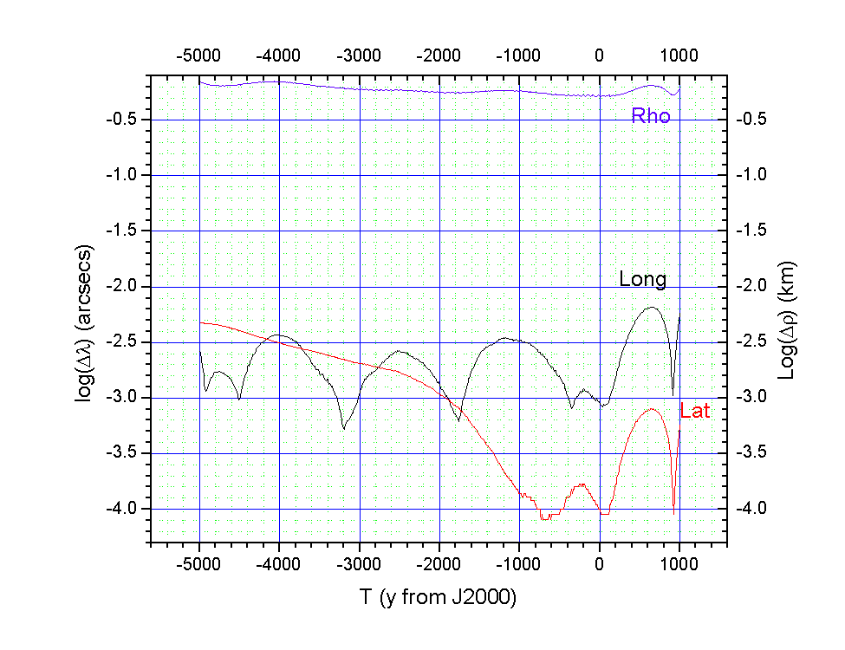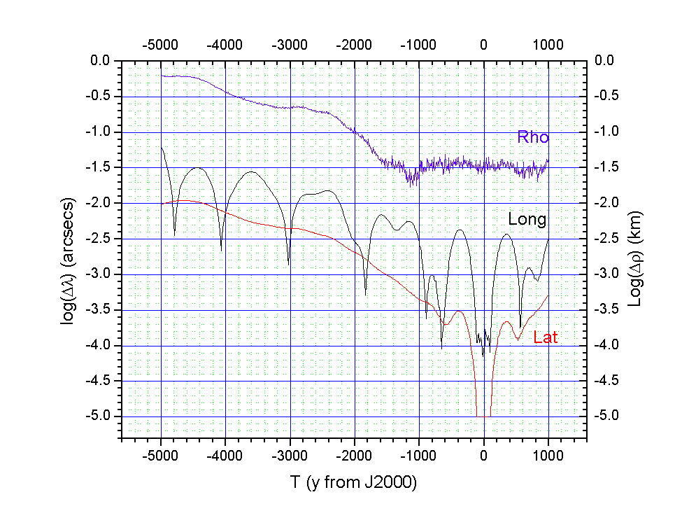
Mercury Venus
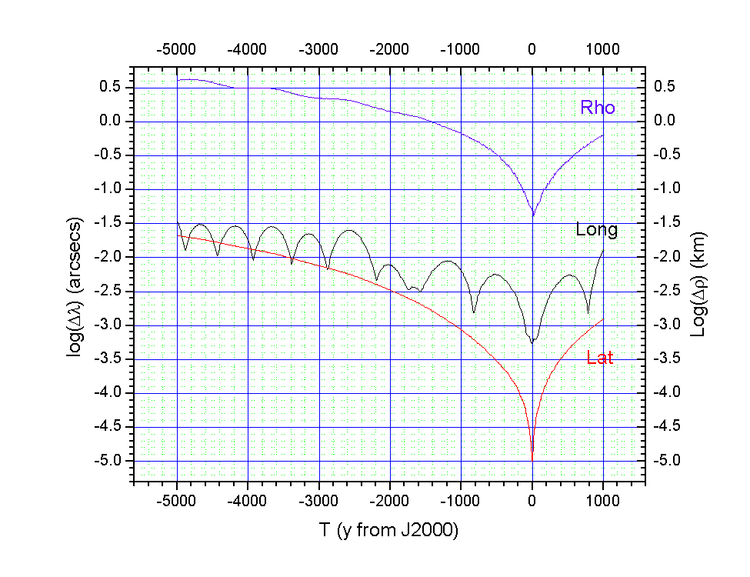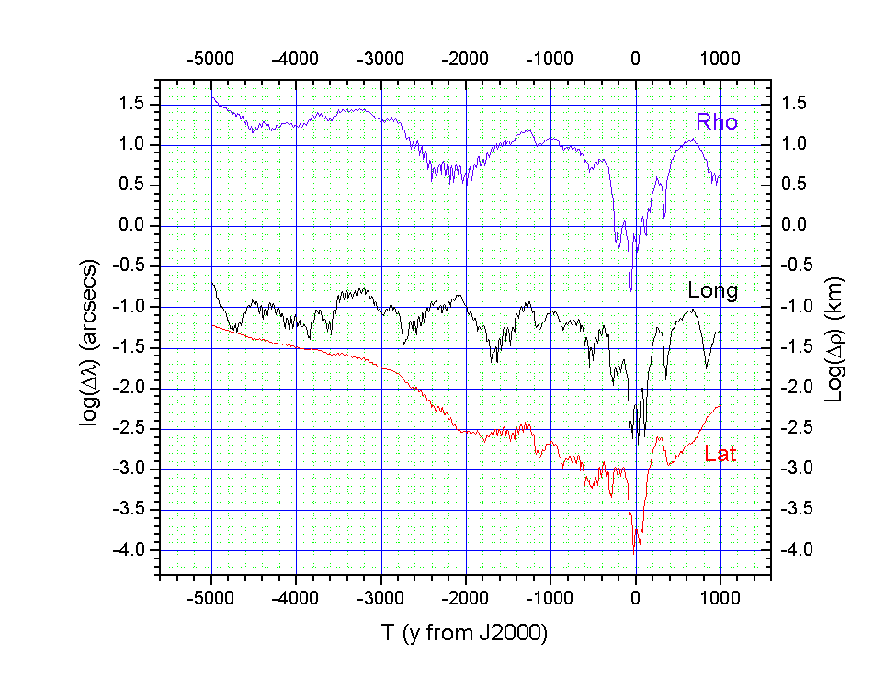
Earth Mars
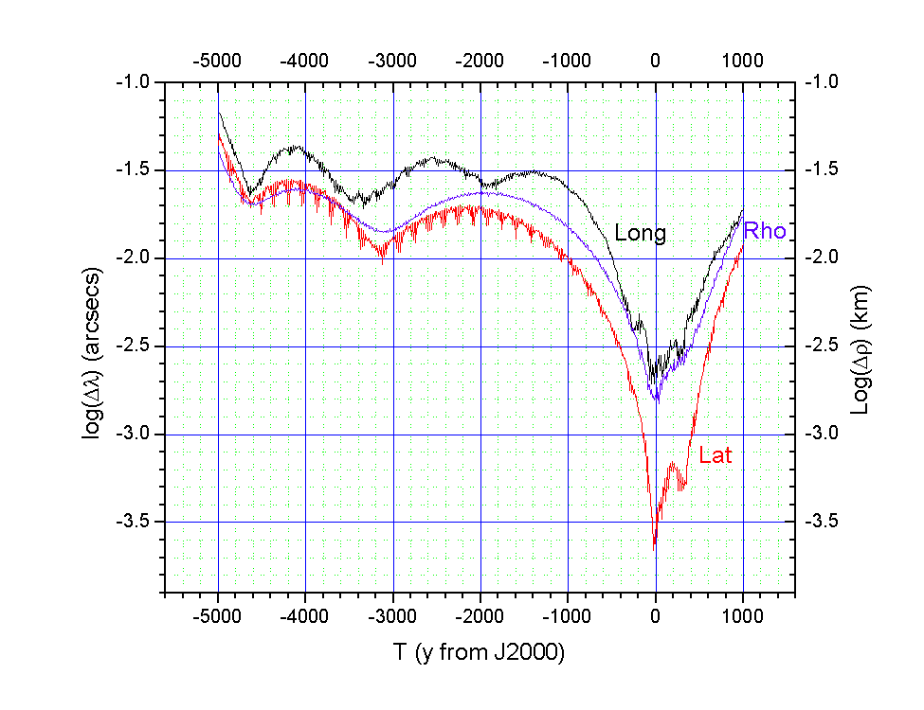
Moon

Figure 1. Maximum heliocentric deviations of SOLEX 11 positions from DE406 for the inner planets and the Moon (Geocentric deviations). The plotted values are the logarithms of the maximum deviations within a range of a few years centered on the given epoch.

Figure 2.
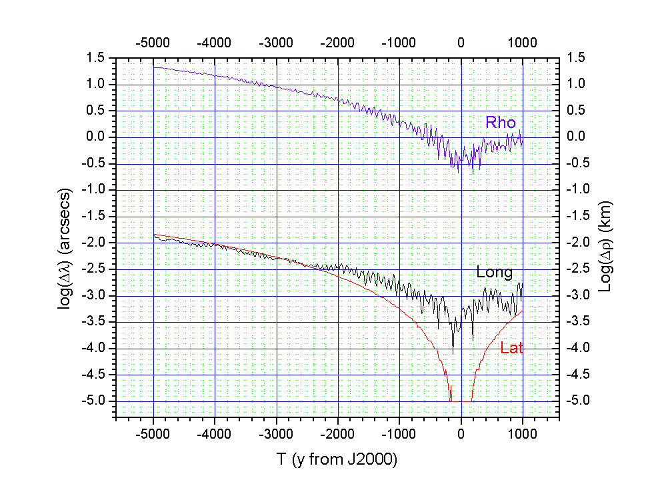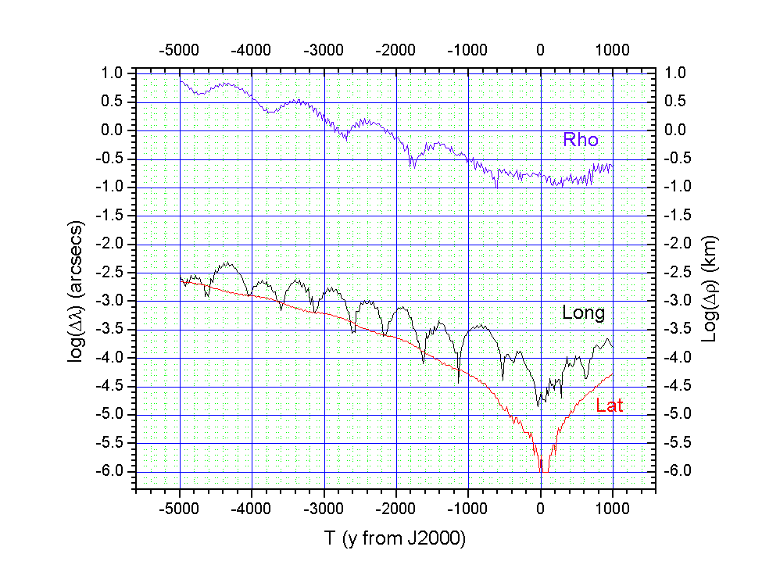
Jupiter Saturn
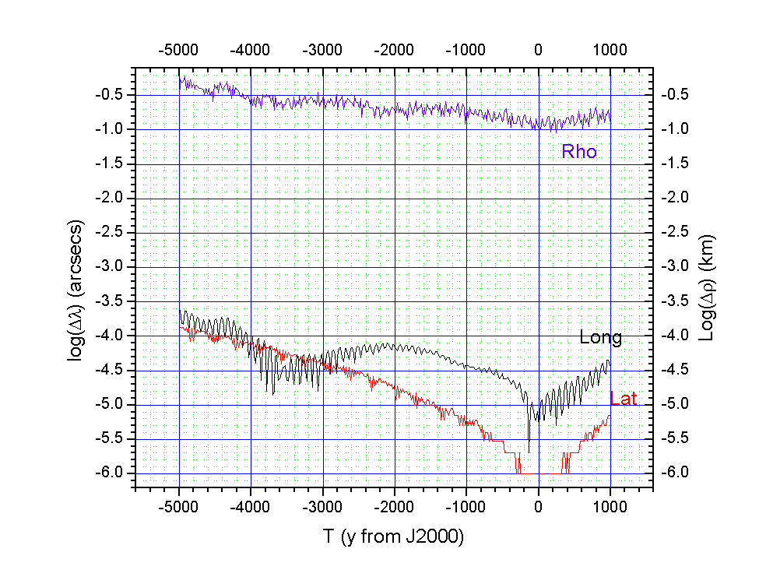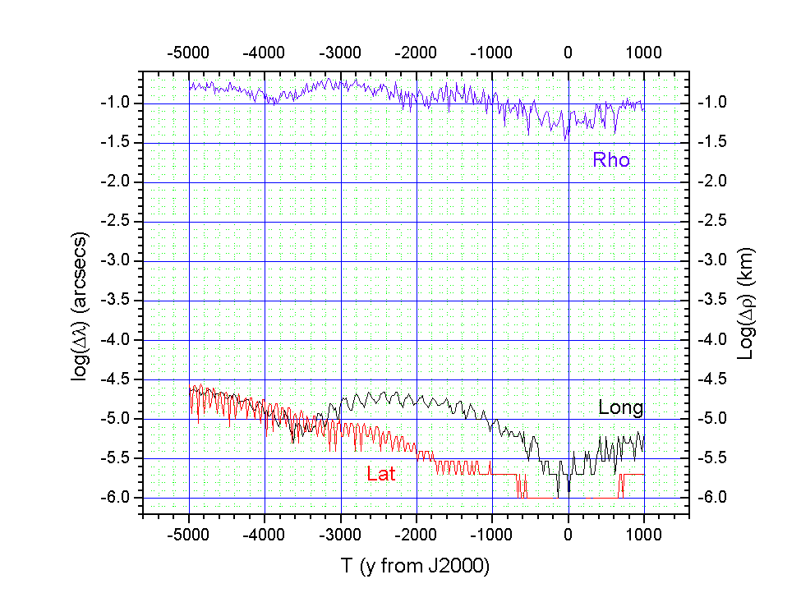
Uranus Neptune
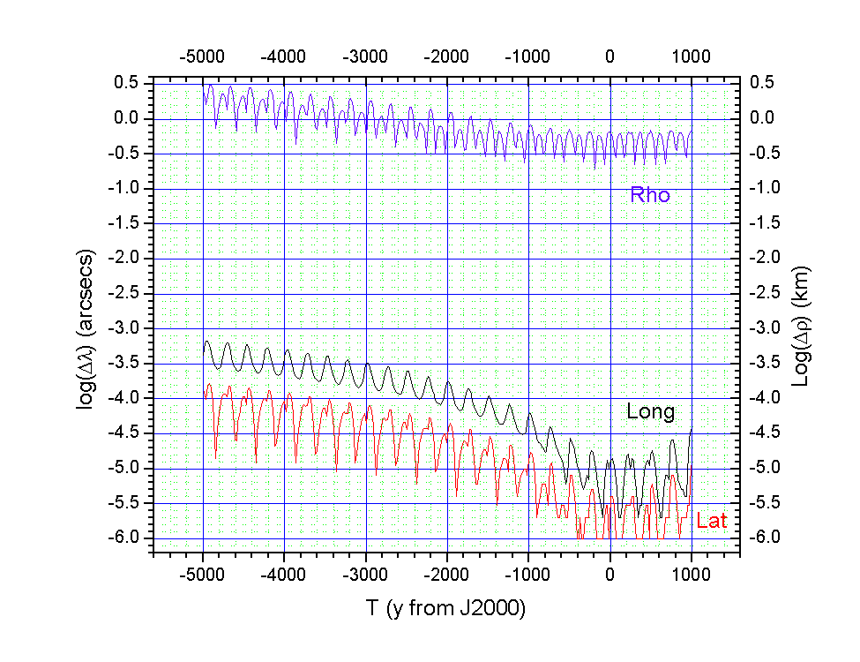
Pluto

Figure 2. Maximum heliocentric deviations of SOLEX 11 positions from DE406 for the outer planets. The plotted values are the logarithms of the maximum deviations within a range of a few years centered on the given epoch.
Figure 3. (*New*)
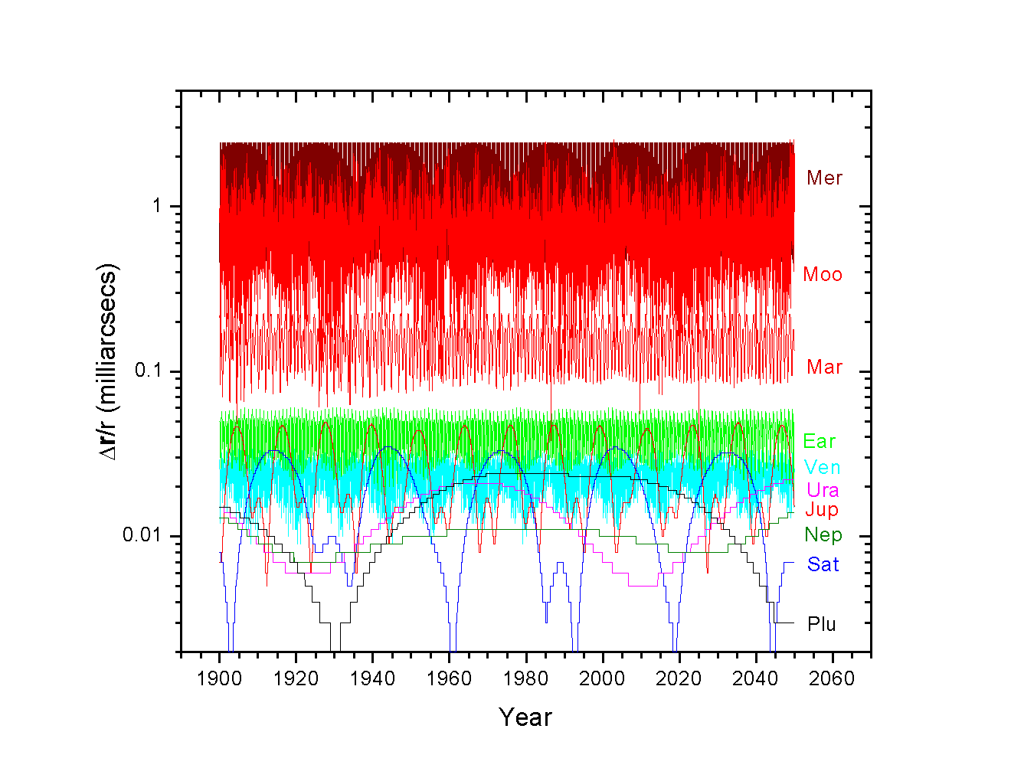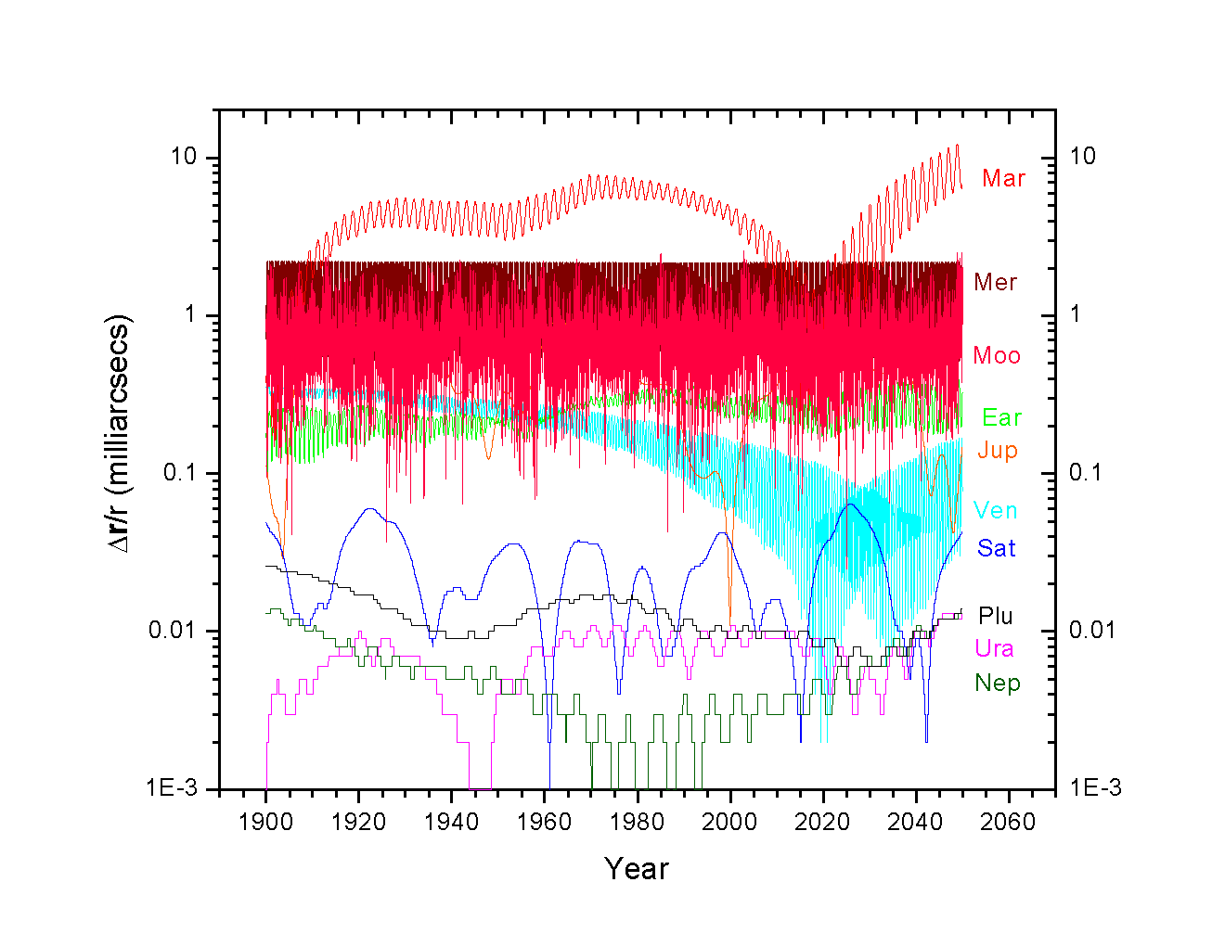
Figure 3. Positional difference between the Solex 10 output and DE421, relative to the radius vector of the respective bodies and expressed in angular form (mas). Upper figure: file FULL421.SLF, containing all the 340 asteroids modelled by DE421, besides Ceres, Pallas and Vesta. Lower figure: option 1 (DE421) of the Main Menu.
Figures 4-13. In all the following figures . (*New*) the plotted relative differences (Δr/r, positional difference divided by the radius vector) are converted from radiants to arcseconds and represent the maximum values reached within the time given in the abscissas.

Figure 4: Planets
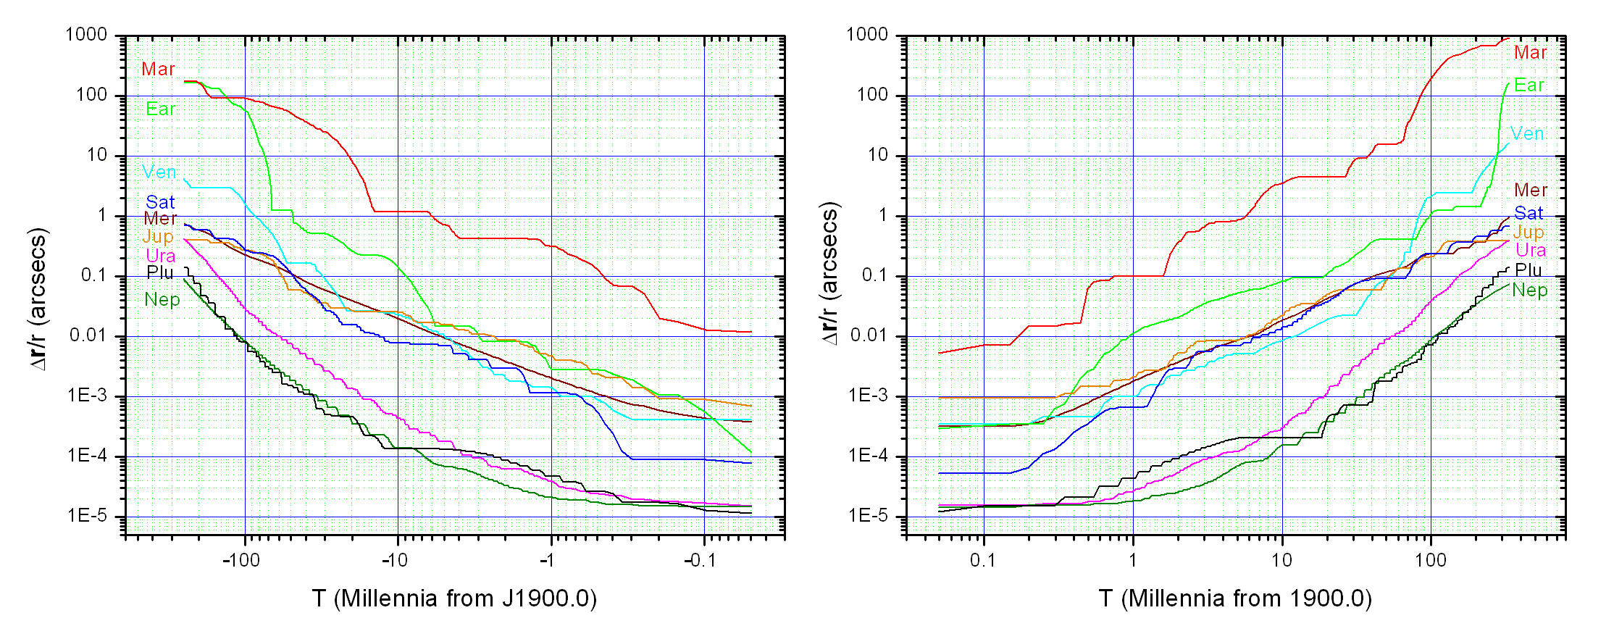
Figure 4. Planets: Difference between the FULL421.SLF integration and the option 1 (DE421) integration. This gives an estimate of the error propagation due to incomplete modelling (missing minor asteroids), the reference ephemeris being the same.

Figure 5: Planets
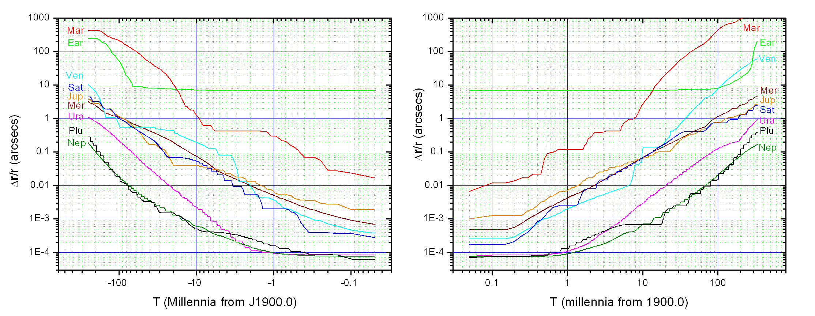

Figure 5. Planets: Difference between the FULL421.SLF integration and the option 2 (DE421-Planets only) integration. This gives an estimate of the error propagation due to incomplete modelling (missing Moon and all asteroids, the reference ephemeris being the same.

Figure 6: Planets
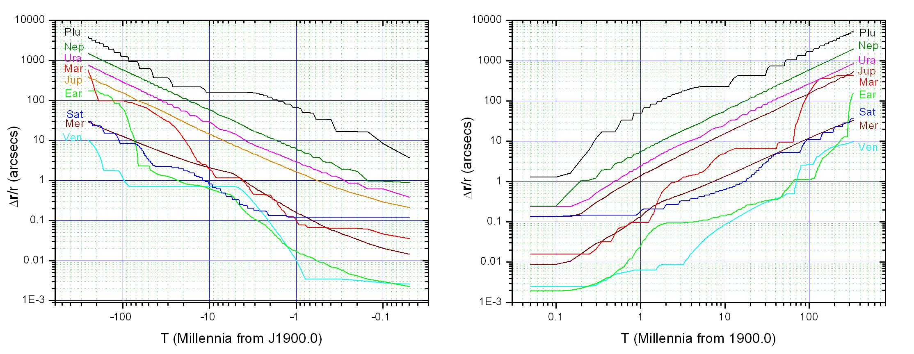

Figure 6. Planets: Difference between the FULL421.SLF integration and the option 3 (DE406) integration. This gives an estimate of the error propagation due both to difference in reference ephemeris (DE421 vs. DE406) and to incomplete modelling (missing minor asteroids).

Figure 7: Planets
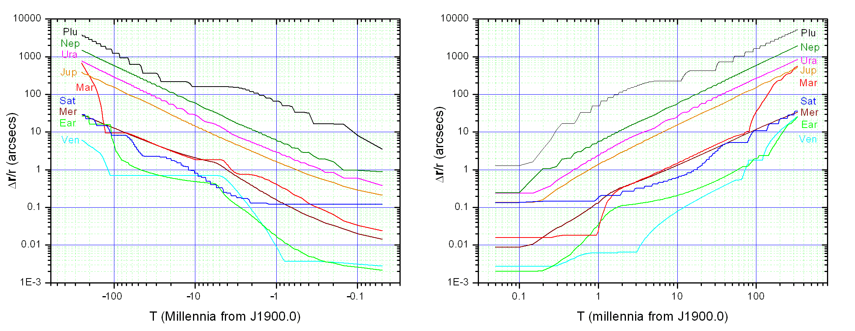

Figure 7. Planets: Difference between the option 1 (DE421) integration and the option 3 (DE406) integration. This gives an estimate of the error propagation due to difference in reference ephemeris (DE421 vs. DE406), the integrated model being the same.

Figure 8: Planets
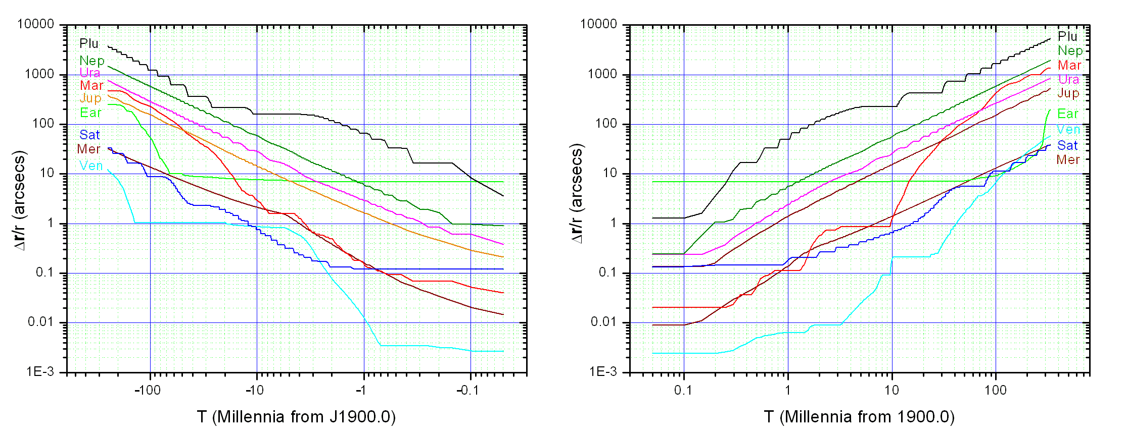
Figure 8. Planets: Difference between the FULL421.SLF integration and the option 4 (DE406 – Planets only) integration. This gives an estimate of the error propagation due to both difference in reference ephemeris (DE421 vs. DE406) and to incomplete modelling (missing Moon and asteroids).

Figure 9: Planets
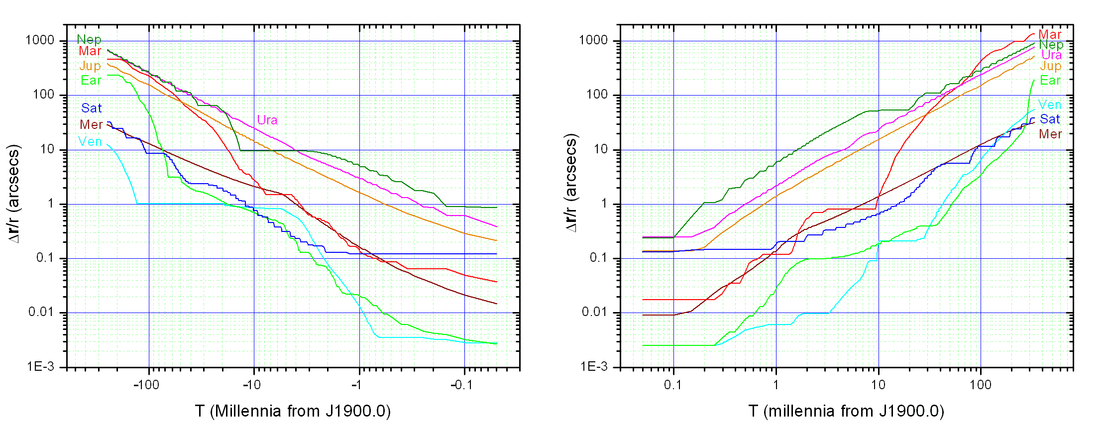
Figure 9. Planets: Difference between the FULL421.SLF integration and the option 5 (DE406 – short) integration. This gives an estimate of the error propagation due both to difference in reference ephemeris (DE421 vs. DE406) and to incomplete modelling (missing asteroids and Pluto).

Figure 10: Planets
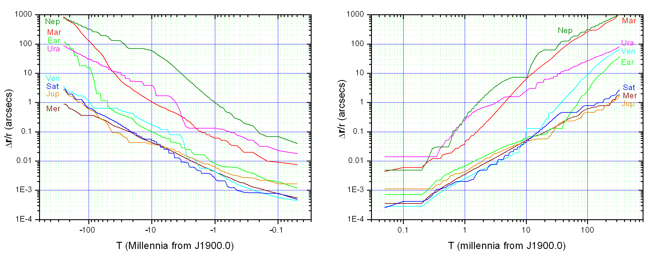

Figure 10. Planets: Difference between the option 3 (DE406) integration and the option 5 (DE406 – short) integration. This gives an estimate of the error propagation due to incomplete modelling (missing asteroids and Pluto).

Figure 11: Moon
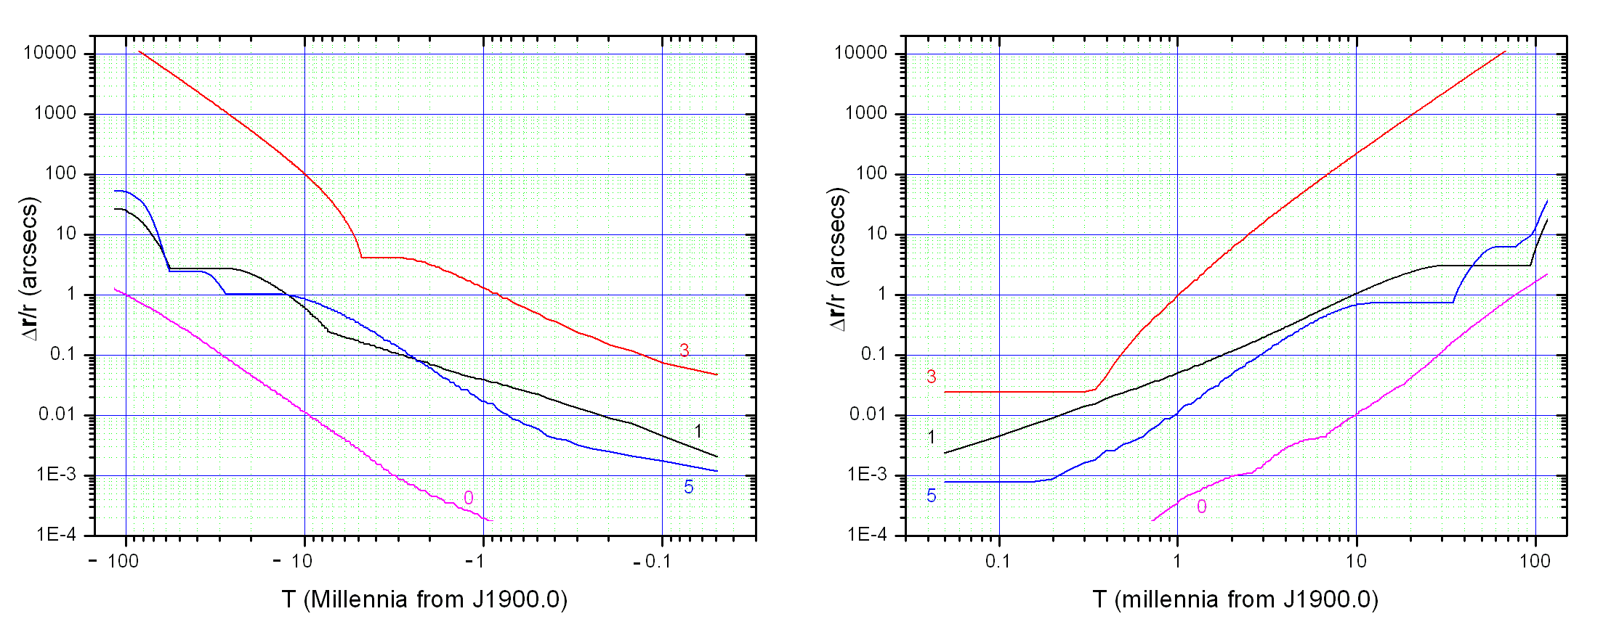
Figure 11. Moon (geocentric). (0) Difference between DE421 (option 1) integrations performed with high and medium order integrators. ((1) Difference between FULL421.SLF and option 1 (DE421) integrations. (3) Difference between FULL421.SLF and option 3 (DE406) integrations. (5) Difference between option 3 (DE406) and option 5 (DE406-short) integrations. Plot 3 gives an estimate of the error propagation due to difference in reference ephemeris (DE421 vs. DE406). Plot 0 gives an estimate of the integration error.

Figure 12: Asteroids
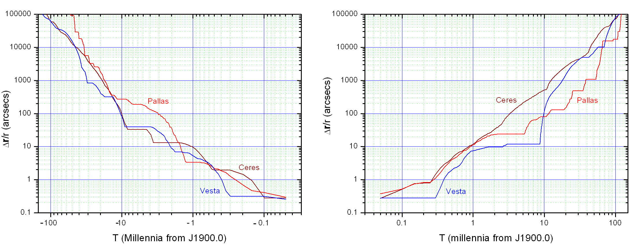

Figure 12. Asteroids: Difference between the FULL421.SLF integration and the option 1 (DE421) integration. This gives an estimate of the error propagation due to incomplete modelling (missing minor asteroids).

Figure 13: Asteroids
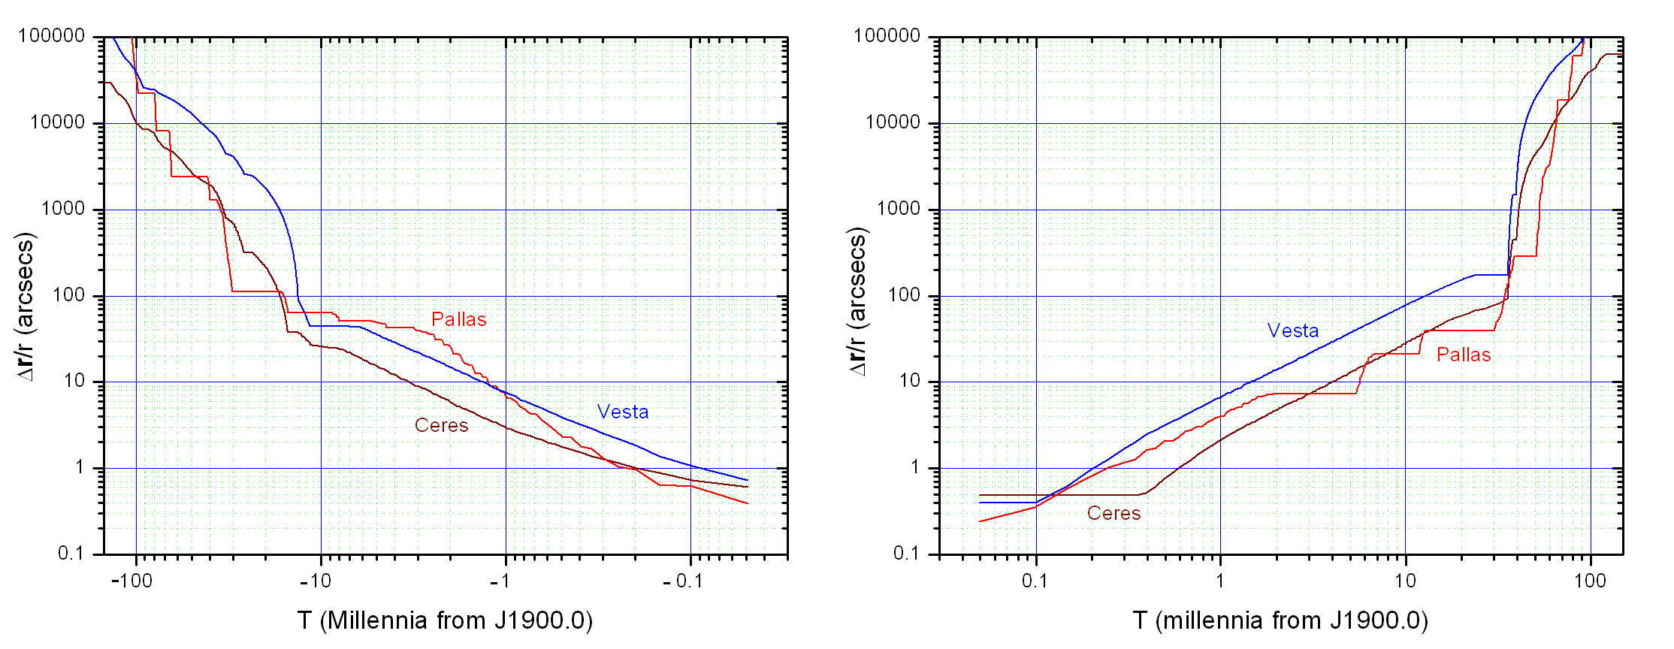

Figure 13. Asteroids: Difference between the option 1 (DE421) integration and the option 3 (DE406) integration. This gives an estimate of the error propagation due to different reference ephemeris. Note the rapid chaotic increase shortly after 10 ky.

Figure 14
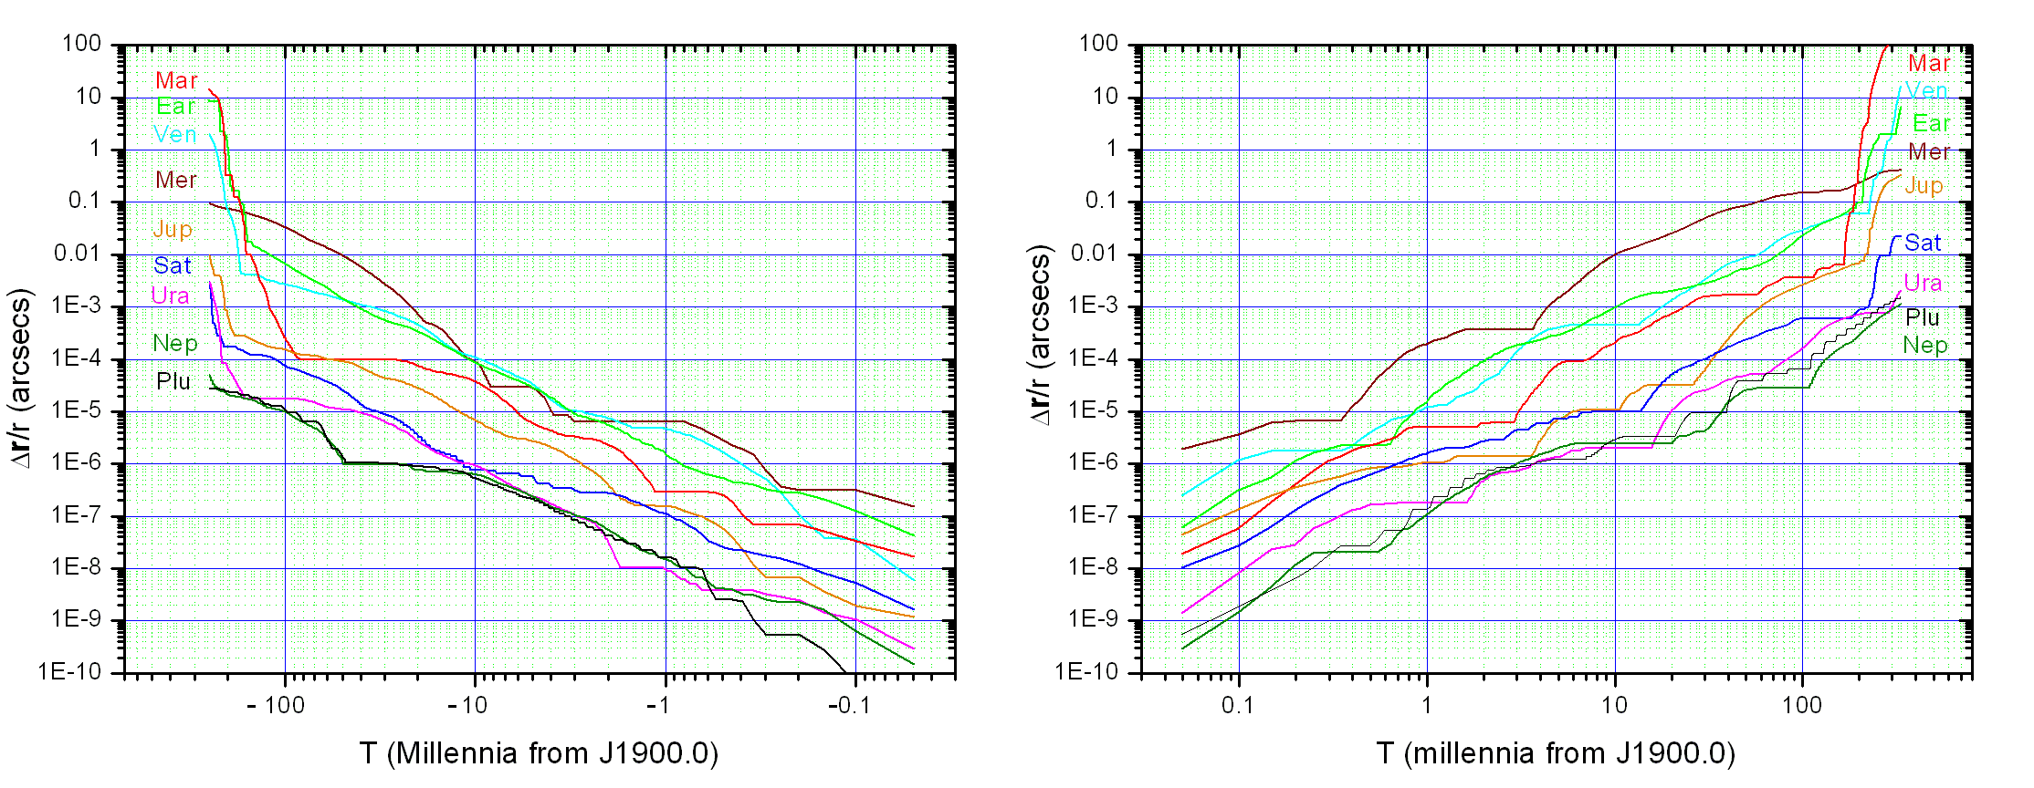

Figure 14. Integration error on planets: Difference between the integration of DE421 (option 1) using high (18) and medium (16) orders of the integrator (Special option F). Note the rapid chaotic increase shortly after 100 ky.

Figure 15
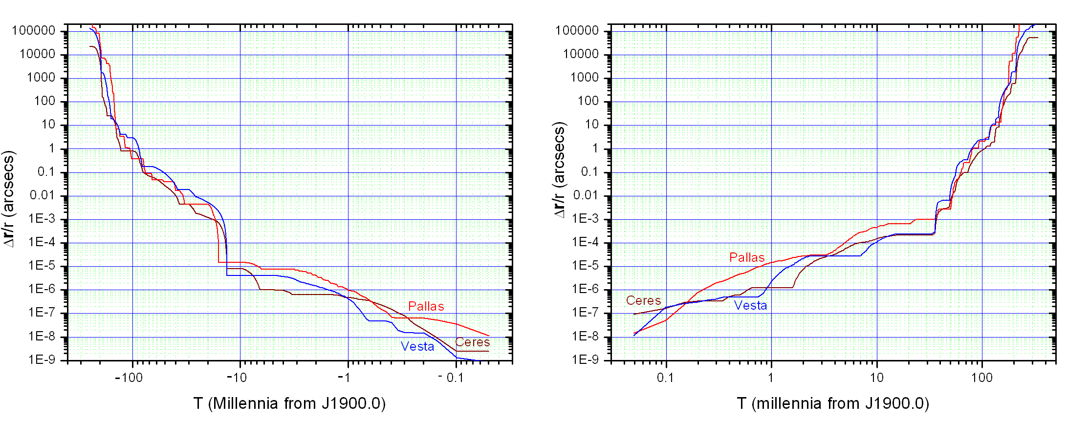

Figure 15. Integration error on asteroids: Difference between the integration of DE421 (option 1) using high (18) and medium (16) orders of the integrator (Special option F). Note the large chaotic increase shortly after 10 ky.

Figure 16
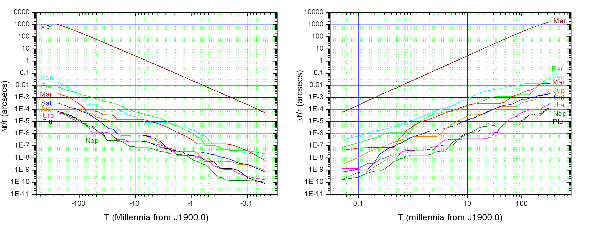
Figure 16. Integration error on “Planets only”: Difference between the integration of DE421 (option 2) using high (18) and medium (16) orders of the integrator (Special option F). The relatively large error on Mercury (compared to Fig. 14) is due to the larger integration stepsize adopted by the “Planets only” options (6d vs. 3d). The integration error on Mercury is reduced by a factor of 1000 by adopting the high integration order (18).
Appendix 1. Handling special perturbations.

Normally, the masses of minor bodies (other than the three “big” asteroids Ceres, Pallas and Vesta) are not considered by Solex 10, unless the bodies are introduced via a SLF (or ELE) input file. Therefore, when a number of asteroids is introduced in the system from the asteroid library, they do not perturb themselves and the rest of the Solar system. Neglecting these perturbations usually has very little effects on the orbits of major planets, but it might have a substantial effect on the orbits of some asteroids. Solex 10 allows to take in account the masses of asteroids in two ways:
The first one is to input the asteroids from the library in the first place, and then using the FINAL.SLF file which is automatically generated (it is suggested to rename it) to re-input the same data. By this method the masses of all the input bodies will be considered.
The second method uses the FINAL.SLX (or SLE) file. If this file is edited (it is suggested to rename it), and a negative integer number is appended to it immediately under its last line, then the absolute value of that number will flag to Solex how many bodies of the file should be considered as having mass. Thus for example if the following SLX file is generated after loading the appropriate asteroids from the library and appending the number [-3] under the last line, then when Solex 10 will input data from

2452500.5
.00006364 .00020355 5.8 -2.832890E-08 Hygiea
4.3432488173445E+02 2.4532914180919E+02 1.4213982266936E+02
-7.4903604267871E+00 1.2166421688214E+01 4.9689092027218E+00
0 0 0 10
.00001003 .0000999 5.9 -3.722725E-08 Iris
2.7436456450136E+02 -1.5965344513580E+02 -3.7753573050049E+01
6.7856212773915E+00 1.8512333351539E+01 8.3533979419389E+00
0 0 0 7
.00003271 .00016305 6.6 -2.804715E-08 Davida
1.5765750181482E+02 3.5080231315676E+02 7.2016534974159E+01
-1.7948983291830E+01 5.3289245035840E+00 6.9083465689167E+00
0 0 0 511
.00000453 .00007665 6.9 -3.620058E-08 Parthenop
-1.9717026646171E+02 3.2116368659631E+02 1.3546487856060E+02
-1.5390409132668E+01 -7.8068846063993E+00 -1.8758529873682E+00
0 0 0 11
.0000018 .0000564 7.6 -3.805692E-08 Victoria
-3.8456619279099E+02 6.9365826180718E+01 -2.5582298783982E+01
6.6710199637201E-01 -1.6357205578379E+01 -5.4473785055443E+00
0 0 0 12
.00000938 .0001038 7.1 -3.447597E-08 Egeria
1.8918075913591E+02 -2.7937734140384E+02 -2.4657536973895E+02
1.4908480248837E+01 8.0143099318961E+00 2.0918378132882E+00
0 0 0 13
-3

this file, the masses of the asteroids Hygiea, Iris and Davida will be considered in all the successive integrations, while those of the remaining ones (Parthenope to Egeria) will not. It should be noted that taking in account minor bodies’ masses can considerably increase the computation time if many new interactions have to be considered. In the above example, taking in account the masses of the first three bodies adds an overhead of 12 more interactions to the “normal” situation in which all minor bodies are treated as massless. Note: a negative number appended to a SLF file will flag how many bodies in total should be considered has having mass. However, as stated before, in absence of an appended negative number SLX files default to all bodies being massless, while SLF files default to all bodies being massive.

Appendix 2. Eclipses, occultations and the PATHMAP4 utility.

When a search for occultations is run (section 3.12), information about the path of each occultation (or eclipse) on the Earth’s surface are written in the files *.OCC, which are named after the names or numbers of the occulting bodies. The occulting bodies are assumed to be spherical.
If the search is run in Geocentric coordinates, then all occultations are recorded, no matter if they take place during daylight time. On the other hand, if the search is run in Topocentric coordinates, the recorded occultations are only those taking place during night time (or twilight), within a given angular distance from the main observation site.
In the *.OCC files, the column headed “Wmin” gives the approximate transverse diameter of the “shadow” in km (if negative, it means that an “annular” eclipse is taking place). The columns headed “HWmin” and “HWmax” give the approximate minimum and maximum half-widths of the “shadow” along its elongation direction. The column headed “Hwerr” gives the estimated transverse uncertainty of the nominal shadow.
The *.OCC files can be processed by the utility PATHMAP4.EXE, which is enclosed in the SOLEX package, producing a map of the occultation. The map is displayed on screen and written to a BMP file (default name is NONAME.BMP) which can then be read by image processors such as MS Paint and others. PATHMAP4 can also be called from within SOLEX immediately after the completion of the occultation search. PATHMAP4 reads a small configuration file named PATHMAP.CFG, which can be edited using a text editor. To edit it from within the PATHMAP4 program, the MS file EDIT.COM must be in the current directory or addressed by the current PATH. Note: the shadow contours plotted in the maps are accurate only in the case of relatively small shadows, such as those given by solar eclipses or asteroidal occultations. In the case of very large shadows (such as those projected by lunar occultations), the contours can be inaccurate, especially when they are close to the polar regions. The data in the .OCC files are nevertheless allways reliable.
Important: Some image processors fail to open the BMP images created by PATHMAP. If this happens, don’t panic. Open the image using MS Paint and save it in some other format (gif, jpg …). The new image should now be successfully opened by your favourite image processor.
PATHMAP4 uses a small configuration file named PATHMAP4.CFG, located in the subdirectory CFG of the Solex home directory. This file can be edited by any text editor (also from within PATHMAP4) by double-clicking on the option “Change Defaults”. An example of the file PATHMAP4.CFG follows:

"NONAME" "Picture FileName"
1280 "Maximum X Width (Pixels)"
1020 "Maximum Y Height (Pixels)"
0.5 "X Border (longitude degrees)"
0.5 "Y Border (latitude degrees)"
16 "Font height (points)"
0 "Text X offset (points)"
-2 "Text Y offset (points)"
1 "Spots to skip"
3 "Unlabeled Spots"
1 "Error Bars (1=yes 0=no)"
1 "Multiple paths (1=yes 0=no)"
0 "Custom Locations (1=yes 0=no)"
0 "Full World map (1=yes 0=no)"

In the above file the editable data are in the first column. Although the second column only contains a description of the data in the first column, it must not be deleted and the double quotes are mandatory. Spacing between the two columns is unimportant and free.
Multiple paths. Except in the case of Solar eclipses, a single .OCC file is written by Solex 10 for a given couple of bodies. This means that, if many occultations take place between two given bodies during the searched interval of time, the corresponding data are appended to the same file. PATHMAP4 can either display all the data included in the .OCC file in the same image, or display them in successive images, according to the selection made for the corresponding flag in PATHMAP4.CFG.
Custom Locations. A file, named SITES.CRD is located in the subdirectory CFG of the Solex100 home directory, containing the geographic coordinates of custom locations can be edited by the user, who can add to it as many locations he wants. A small example is provided (it contains the coordinates of my favourite place in the Alps). The custom locations will be displayed in the maps by activating the corresponding flag in PATHMAP4.CFG.

